‘Email notification’ on successful completion of task:
There is no direct setting in QlikView to notify user’s on successful completion of task. But alternate options are available when using ‘Publisher License’.
Note: This cannot be achieved with just ‘QlikView Server license’.
Option 1:
1. Navigate to the screen as below mentioned.
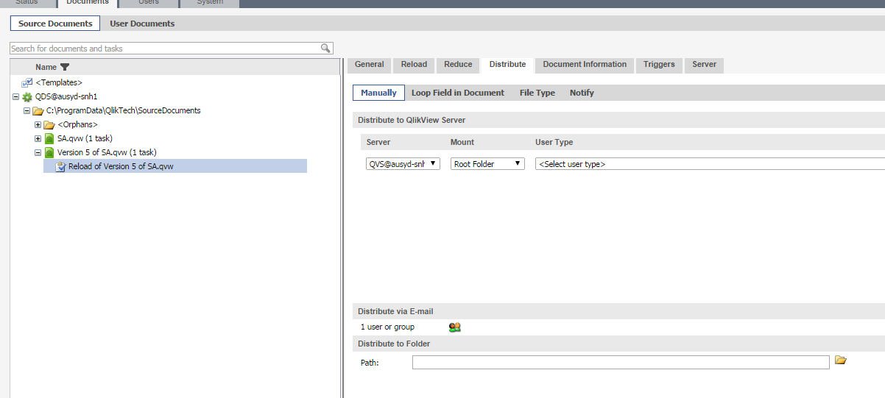
2. Enter email id under ‘Distribute via E-mail’. So once a task completes successfully an email will be sent with QVW to elected users.
Option 2:
1. Select a recipient as below
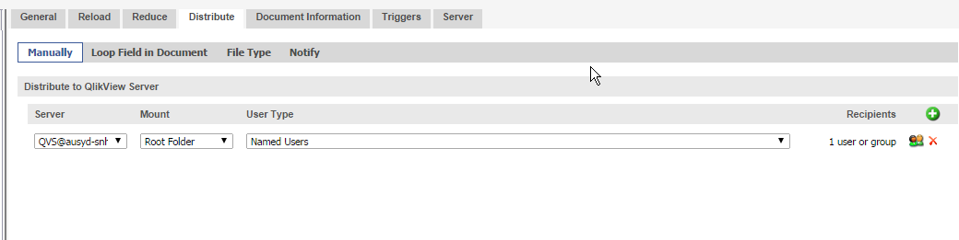
2. Tick the box ‘Send notification e-mail to recipients’ under Notify tab.
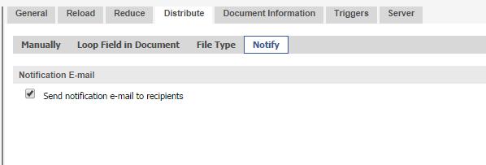

Option 3:
- Use ‘Loop Field in Document’ settings as shown below.
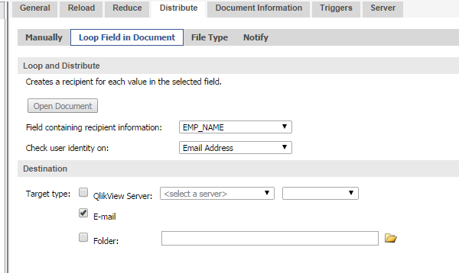
Note: For further clarification on each setting, please use Help utility as shown below.
