Qlik Connector for SAP - Objects and Roles
There are two types of Qlik SAP connector transports. One type contains the Qlik SAP connector objects (like ABAP programs, function modules and dictionary objects) and the other one contains the Qlik SAP connector roles.
The Qlik SAP connector roles contain the Authorization objects that are checked when using the connectors. Authorization objects may be checked both in the Qlik SAP connector code and in standard SAP code called from the Qlik code. It is not mandatory to import and use the Qlik roles. It is allowed for customers to create their own authorizations. It is also allowed for customers to copy or modify the Qlik roles.
Some facts about the roles:
QTQVCADMIN
There are some Qlik transactions in the SAP GUI. Most of them require that this role is assigned to the user.
QTQVCACCESS
To be used by a connector back-end user for doing extraction jobs from Qlik. See ‘Access control’ in the online manual for further information.
QTQVCEXTRACTOR
To be used by Extractor Connector Back-end user for doing extraction jobs from Qlik.
QTQVCEXTRADM
This role is used to activate and generate the extractors in an SAP system. It can also be used to test Extractors in the SAP system and to monitor Extractor jobs.
QTQVCEXTRSETUP
This role can be used to create, delete, and verify the setup of the logical system in an SAP system for later use by the Extractor Connector. It can also be used for administration tasks like migrating Extractors and Extractor Environment.
QTQVCBWACCESS
To be used by OLAP, DSO/ODS, BEx and InfoProvider Connectors back-end user for doing extraction jobs from SAP BI/BW system from Qlik.
The Qlik SAP connector objects are found in two Packages /QTQVC/QTDEV and /QTQVC/QTDEV_BW (BEx and InfoProvider connectors). All objects are prefixed with the Qlik reserved Namespace at SAP, /QTQVC/. This is done to make them unique for Qlik. If the objects have been imported to the SAP system, it is possible to import a Qlik deletion transport to remove them again.
When the Qlik objects performs updates to SAP database objects, it is always done by calling standard SAP function modules and programs to assure that the updates are done according to SAP rules and standards.
For detailed information about how each connector is working, read the online manual.
Below are screenshots from transaction SE80 in SAP where all Qlik objects can be displayed. After that all roles with their authorizations are listed (from transaction PFCG).
Objects
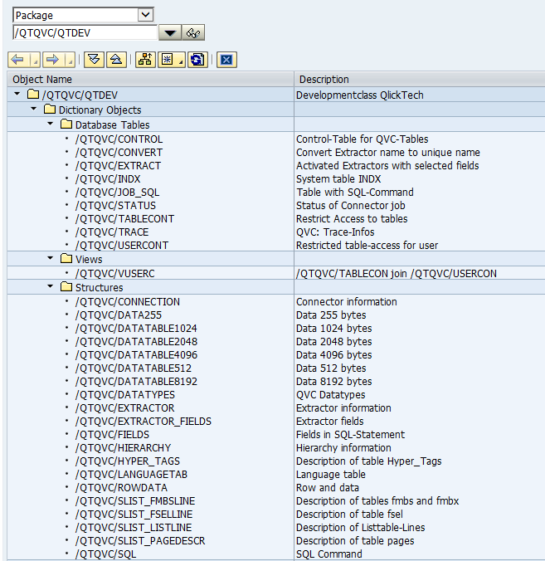
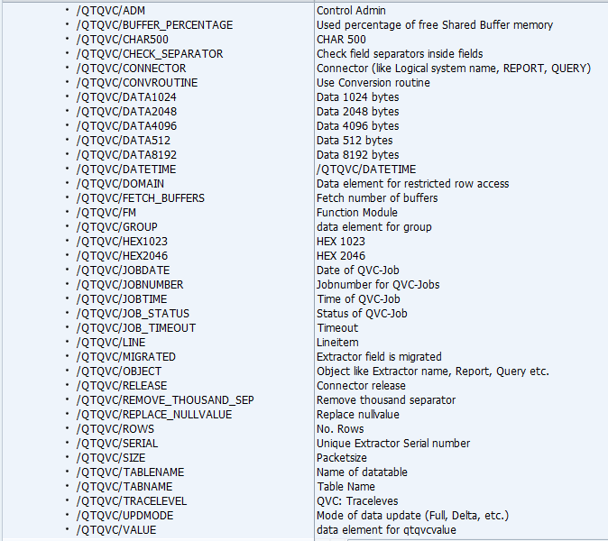
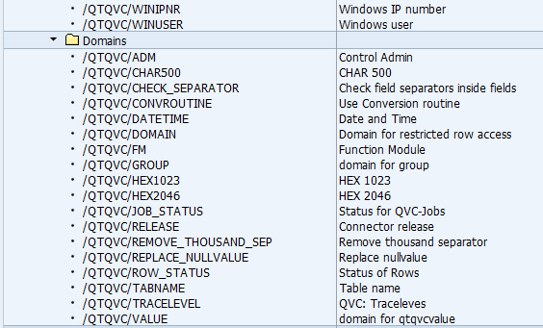
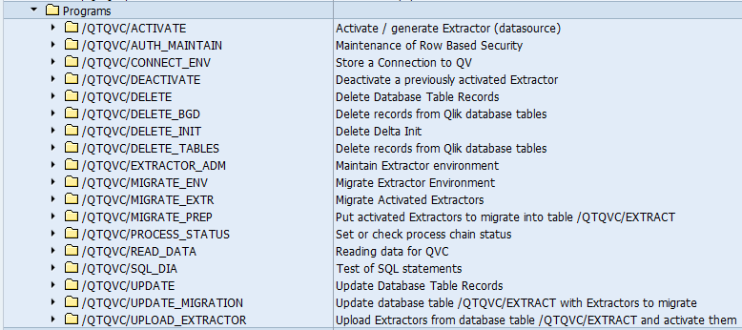
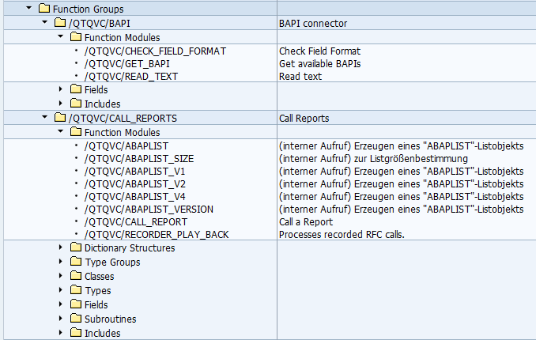
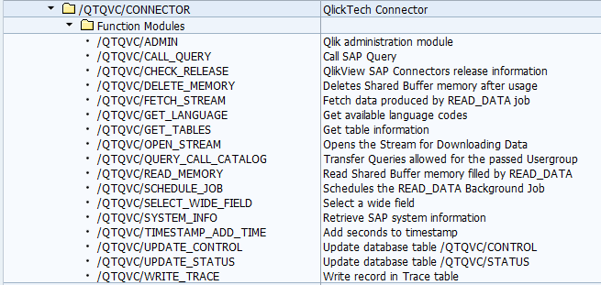
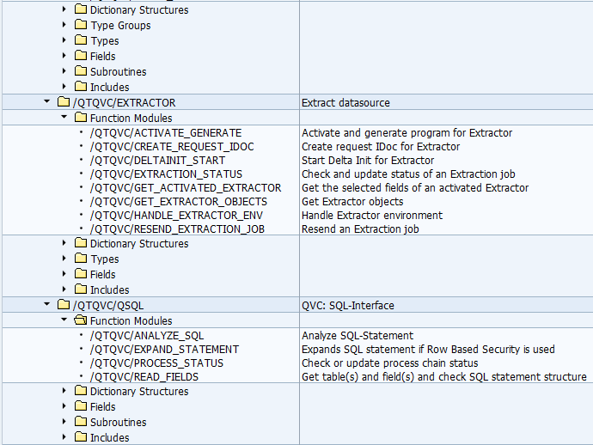
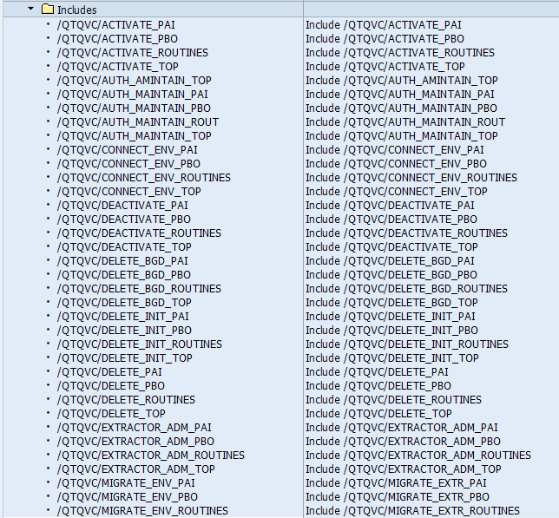
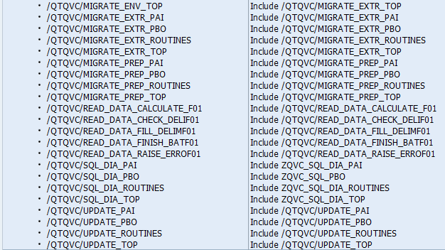
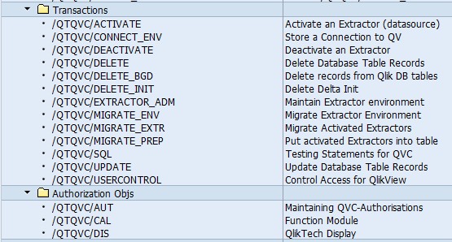

/QTQVC/QTDEV_BW
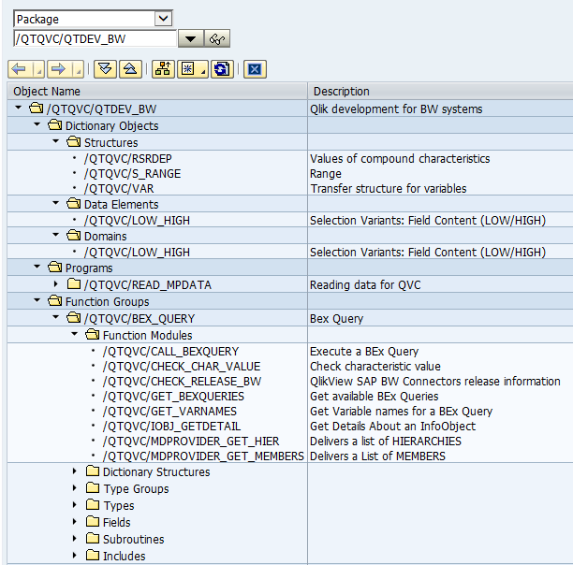
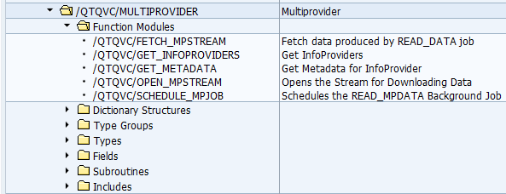
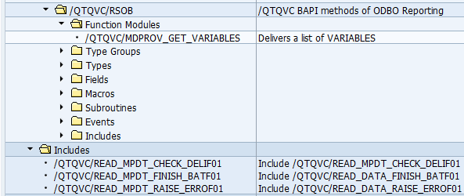

Roles
QTQVCACCESS QlikView Connector User profile
|
|-- Manually Cross-application Authorization Objects AAAB
| |
| |-- Manually Authorization Check for RFC Access S_RFC
| | |
| | --- Manually Authorization Check for RFC Access QTQVCPROF101
| | |
| | |----- Activity 16 ACTVT
| | |----- Name of RFC to be protected * RFC_NAME
| | ------ Type of RFC object to be prote FUGR RFC_TYPE
| |
| --- Manually Transaction Code Check at Transaction Start S_TCODE
| |
| --- Manually Transaction Code Check at Transaction Start QTQVCPROF101
| |
| ------ Transaction Code /QTQVC/SQL, /QTQVC/USERCONTROL, SA38, SU53 TCD
|
|-- Manually Basis: Administration BC_A
| |
| |-- Manually System Authorizations S_ADMI_FCD
| | |
| | --- Manually System Authorizations QTQVCPROF100
| | |
| | ------ System administration function ST0R S_ADMI_FCD
| |
| |-- Manually Background Processing: Background Administrator S_BTCH_ADM
| | |
| | --- Manually Background Processing: Background Administrator QTQVCPROF101
| | |
| | ------ Background administrator ID Y BTCADMIN
| |
| --- Inactiv Manually Table Maintenance (via standard tools such as SM30) S_TABU_DIS
| |
| --- Inactiv Manually Table Maintenance (via standard tools such as SM30) QTQVCPROF101
| |
| |-----Inactiv Activity 03 ACTVT
| ------Inactiv Authorization Group * DICBERCLS
|
|-- Manually Basis - Development Environment BC_C
| |
| --- Manually ABAP: Program Flow Checks S_PROGRAM
| |
| --- Manually ABAP: Program Flow Checks QTQVCPROF100
| |
| |----- User action ABAP/4 program BTCSUBMIT, SUBMIT, VARIANT P_ACTION
| ------ Authorization group ABAP/4 pro * P_GROUP
|
--- Manually Qlikview ZQTV
|
|-- Manually Function Module /QTQVC/CAL
| |
| --- Manually Function Module QTQVCPROF100
| |
| ------ Function Module * /QTQVC/FM
|
--- Manually QlikTech Display /QTQVC/DIS
|
--- Manually QlikTech Display QTQVCPROF100
|
------ Table Name * /QTQVC/TAB

QTQVCADMIN QlikView Connector Admin profile
|
|-- Manually Cross-application Authorization Objects AAAB
| |
| --- Manually Transaction Code Check at Transaction Start S_TCODE
| |
| --- Manually Transaction Code Check at Transaction Start QTQVC_ADMI01
| |
| ------ Transaction Code /QTQVC/AUTH_MAINTAIN, /QTQVC/USERCONTROL TCD
|
--- Manually Qlikview ZQTV
|
--- Manually Maintaining QVC-Authorisations /QTQVC/AUT
|
--- Manually Maintaining QVC-Authorisations QTQVC_ADMI00
|
------ Control Admin * /QTQVC/ADM

QTQVCEXTRADM EXTRACTOR ADM
|
|-- Manually Cross-application Authorization Objects AAAB
| |
| --- Manually Transaction Code Check at Transaction Start S_TCODE
| |
| --- Manually Transaction Code Check at Transaction Start T-ED55072600
| |
| ------ Transaction Code /QTQVC/ACTIVATE, /QTQVC/DEACTIVATE, /QTQVC/DELETE, /QTQVC/DELETE_INIT,<...> TCD
|
|-- Manually Basis: Administration BC_A
| |
| --- Inactiv Manually Table Maintenance (via standard tools such as SM30) S_TABU_DIS
| |
| --- Inactiv Manually Table Maintenance (via standard tools such as SM30) T-ED55072600
| |
| |-----Inactiv Activity 02, 03 ACTVT
| ------Inactiv Authorization Group * DICBERCLS
|
|-- Manually Basis - Central Functions BC_Z
| |
| --- Manually WFEDI: S_IDOCDEFT - Access to IDoc Development S_IDOCDEFT
| |
| --- Manually WFEDI: S_IDOCDEFT - Access to IDoc Development T-ED55072600
| |
| |----- Activity 01, 02, 03 ACTVT
| |----- Extension * EDI_CIM
| |----- Basic type RSSEND, ZSQ* EDI_DOC
| ------ Transaction Code WE30 EDI_TCD
|
|-- Manually Authorizations: BW Service API RO
| |
| |-- Manually Remote Content Activation of SAPI DataSources from a BW S_RO_BCTRA
| | |
| | --- Manually Remote Content Activation of SAPI DataSources from a BW T-ED55072600
| | |
| | ------ Activity 07 ACTVT
| |
| --- Manually SAP DataSource Authorizations S_RO_OSOA
| |
| --- Manually SAP DataSource Authorizations T-ED55072600
| |
| |----- Activity 03 ACTVT
| |----- DataSource * OLTPSOURCE
| |----- DataSource Application Compone * OSOAAPCO
| ------ Subobject for DataSource DATA OSOAPART
|
--- Manually Qlikview ZQTV
|
--- Manually Function Module /QTQVC/CAL
|
--- Manually Function Module T-ED55072600
|
------ Function Module * /QTQVC/FM

QTQVCEXTRSETUP SETUP EXTRACTOR
|
|-- Manually Cross-application Authorization Objects AAAB
| |
| |-- Manually Administration for RFC Destination S_RFC_ADM
| | |
| | --- Manually Administration for RFC Destination T-ED55072500
| | |
| | |----- Activity 01, 02, 03, 06, 36 ACTVT
| | |----- Internet Communication Framewo * ICF_VALUE
| | |----- Logical Destination (Specified * RFCDEST
| | ------ Type of Entry in RFCDES 3, T RFCTYPE
| |
| --- Manually Transaction Code Check at Transaction Start S_TCODE
| |

| --- Manually Transaction Code Check at Transaction Start T-ED55072500
| |
| ------ Transaction Code /QTQVC/EXTRACTOR_ADM, /QTQVC/MIGRATE_EXTR, /QTQVC/MIGRATE_PREP, SM37, <...> TCD
|
|-- Manually Basis: Administration BC_A
| |
| --- Manually Authorization for file access S_DATASET
| |
| --- Manually Authorization for file access T-ED55072500
| |
| |----- Activity * ACTVT
| |----- Physical file name * FILENAME
| ------ Program Name with Search Help * PROGRAM
|
|-- Manually Basis - Development Environment BC_C
| |
| --- Manually Transport Organizer S_TRANSPRT
| |
| --- Manually Transport Organizer T-ED55072500
| |
| |----- Activity * ACTVT
| ------ Request Type (Change and Trans * TTYPE
|
|-- Manually Basis - Central Functions BC_Z
| |
| --- Manually WFEDI: S_IDOCDEFT - Access to IDoc Development S_IDOCDEFT
| |
| --- Manually WFEDI: S_IDOCDEFT - Access to IDoc Development T-ED55072500
| |
| |----- Activity 01, 02, 03, 06 ACTVT
| |----- Extension * EDI_CIM
| |----- Basic type RSSEND, ZSQ* EDI_DOC
| ------ Transaction Code WE30 EDI_TCD
|
--- Manually Qlikview ZQTV
|
|-- Manually Maintaining QVC-Authorisations /QTQVC/AUT
| |
| --- Manually Maintaining QVC-Authorisations T-ED55072500
| |
| ------ Control Admin * /QTQVC/ADM
|
--- Manually Function Module /QTQVC/CAL
|
--- Manually Function Module T-ED55072500
|
------ Function Module * /QTQVC/FM

QTQVCEXTRACTOR QVEXTRACTOR
|
|-- Manually Cross-application Authorization Objects AAAB
| |
| |-- Manually ALE/EDI: Receiving IDocs via RFC B_ALE_RECV
| | |
| | --- Manually ALE/EDI: Receiving IDocs via RFC T-ED55072400
| | |
| | ------ Message Type RSRQST EDI_MES
| |
| |-- Manually Authorization Check for RFC Access S_RFC
| | |
| | --- Manually Authorization Check for RFC Access T-ED55072400
| | |
| | |----- Activity 16 ACTVT
| | |----- Name of RFC to be protected * RFC_NAME
| | ------ Type of RFC object to be prote FUGR RFC_TYPE
| |
| |-- Manually Administration for RFC Destination S_RFC_ADM
| | |
| | --- Manually Administration for RFC Destination T-ED55072400
| | |
| | |----- Activity 36 ACTVT
| | |----- Internet Communication Framewo * ICF_VALUE
| | |----- Logical Destination (Specified * RFCDEST
| | ------ Type of Entry in RFCDES T RFCTYPE
| |
| --- Manually Transaction Code Check at Transaction Start S_TCODE
| |
| --- Manually Transaction Code Check at Transaction Start T-ED55072400
| |
| ------ Transaction Code /QTQVC/SQL, RSA3, RSA6, SE16, SM50, SM51, SM58, SU53 TCD
|
|-- Manually Basis: Administration BC_A
| |
| |-- Manually System Authorizations S_ADMI_FCD
| | |
| | --- Manually System Authorizations T-ED55072400
| | |
| | ------ System administration function NADM, ST0R S_ADMI_FCD
| |
| |-- Manually Archiving S_ARCHIVE
| | |
| | --- Manually Archiving T-ED55072400
| | |
| | |----- Activity 03 ACTVT
| | |----- Application area BW APPLIC
| | ------ Archiving Object BWREQARCH ARCH_OBJ
| |
| |-- Manually Background Processing: Operations on Background Jobs S_BTCH_JOB
| | |
| | --- Manually Background Processing: Operations on Background Jobs T-ED55072400
| | |
| | |----- Job operations RELE JOBACTION
| | ------ Summary of jobs for a group * JOBGROUP
| |
| |-- Manually Administration Functions in Change and Transport System S_CTS_ADMI
| | |
| | --- Manually Administration Functions in Change and Transport System T-ED55072400
| | |
| | ------ Administration Tasks for Chang TABL CTS_ADMFCT
| |
| |-- Manually Spool: Device authorizations S_SPO_DEV
| | |
| | --- Manually Spool: Device authorizations T-ED55072400
| | |
| | ------ Spool: Long device names * SPODEVICE
| |
| --- Manually Table Maintenance (via standard tools such as SM30) S_TABU_DIS
| |
| --- Manually Table Maintenance (via standard tools such as SM30) T-ED55072400
| |
| |----- Activity 03 ACTVT
| ------ Authorization Group * DICBERCLS
|
|-- Manually Basis - Development Environment BC_C
| |
| --- Manually ABAP Workbench S_DEVELOP
| |
| --- Manually ABAP Workbench T-ED55072400
| |
| |----- Activity 03, 16 ACTVT
| |----- Package /QTQVC/QTDEV, SRFC DEVCLASS
| |----- Object name * OBJNAME
| |----- Object type * OBJTYPE
| ------ Authorization group ABAP/4 pro * P_GROUP
|
|-- Manually Basis - Central Functions BC_Z
| |
| |-- Manually WFEDI: S_IDOCDEFT - Access to IDoc Development S_IDOCDEFT
| | |
| | --- Manually WFEDI: S_IDOCDEFT - Access to IDoc Development T-ED55072400
| | |
| | |----- Activity 01, 02, 03 ACTVT
| | |----- Extension * EDI_CIM
| | |----- Basic type RSSEND, ZSQ* EDI_DOC
| | ------ Transaction Code WE02, WE30 EDI_TCD
| |
| --- Manually WFEDI: S_IDOCMONI - Access to IDoc Monitoring S_IDOCMONI
| |
| --- Manually WFEDI: S_IDOCMONI - Access to IDoc Monitoring T-ED55072400
| |
| |----- Activity 02, 03 ACTVT
| |----- Direction for IDoc * EDI_DIR
| |----- Message Type * EDI_MES
| |----- Partner number * EDI_PRN
| |----- Partner Type * EDI_PRT
| ------ Transaction Code WE02, WE30 EDI_TCD
|
|-- Manually Authorizations: BW Service API RO
| |
| |-- Manually Remote Content Activation of SAPI DataSources from a BW S_RO_BCTRA
| | |
| | --- Manually Remote Content Activation of SAPI DataSources from a BW T-ED55072400
| | |
| | ------ Activity 07 ACTVT
| |
| --- Manually SAP DataSource Authorizations S_RO_OSOA
| |
| --- Manually SAP DataSource Authorizations T-ED55072400
| |
| |----- Activity 03 ACTVT
| |----- DataSource * OLTPSOURCE
| |----- DataSource Application Compone * OSOAAPCO
| ------ Subobject for DataSource DATA OSOAPART
|
--- Manually Qlikview ZQTV
|
--- Manually Function Module /QTQVC/CAL
|
--- Manually Function Module T-ED55072400
|
------ Function Module * /QTQVC/FM

QTQVCBWACCESS QlikView authorisation for OLAP and DSO Conne
|
|-- Manually Cross-application Authorization Objects AAAB
| |
| --- Manually Authorization Check for RFC Access S_RFC
| |
| --- Manually Authorization Check for RFC Access QTQVCBWACC00
| |
| |----- Activity 16 ACTVT
| |----- Name of RFC to be protected OCSB, RFC1, RRT0, RSAB, RSOB, RSODSO_BAPI, SDIFRUNTIME, SRTT, SYST, SYSU RFC_NAME
| ------ Type of RFC object to be prote FUGR RFC_TYPE
|
|-- Manually Basis: Administration BC_A
| |
| --- Manually Authorization for Organizational Unit S_TABU_LIN
| |
| --- Manually Authorization for Organizational Unit QTQVCBWACC00
| |
| |----- Activity * ACTVT
| |----- Organization criterion for key * ORG_CRIT
| |----- Org. crit. attribute 1 * ORG_FIELD1
| |----- Org. crit. attribute 2 * ORG_FIELD2
| |----- Org. crit. attribute 3 * ORG_FIELD3
| |----- Org. crit. attribute 4 * ORG_FIELD4
| |----- Org. crit. attribute 5 * ORG_FIELD5
| |----- Org. crit. attribute 6 * ORG_FIELD6
| |----- Org. crit. attribute 7 * ORG_FIELD7
| ------ Org. crit. attribute 8 * ORG_FIELD8
|
--- Manually Business Information Warehouse RS
|
|-- Manually BI Analysis Authorizations in Role S_RS_AUTH
| |
| --- Manually BI Analysis Authorizations in Role QTQVCBWACC00
| |
| ------ BI Analysis Authorizations: Na 0BI_ALL BIAUTH
|
|-- Manually Business Explorer - Components S_RS_COMP
| |
| --- Manually Business Explorer - Components QTQVCBWACC00
| |
| |----- Activity 03, 16, 22 ACTVT
| |----- InfoArea * RSINFOAREA
| |----- InfoCube * RSINFOCUBE
| |----- Name (ID) of a reporting compo * RSZCOMPID
| ------ Type of a reporting component REP RSZCOMPTP
|
|-- Manually Business Explorer - Components: Enhancements to the Owner S_RS_COMP1
| |
| --- Manually Business Explorer - Components: Enhancements to the Owner QTQVCBWACC00
| |
| |----- Activity 03, 16, 22 ACTVT
| |----- Name (ID) of a reporting compo * RSZCOMPID
| |----- Type of a reporting component * RSZCOMPTP
| ------ Owner (Person Responsible) for * RSZOWNER
|
|-- Manually Business Explorer - Enterprise Reports S_RS_ERPT
| |
| --- Manually Business Explorer - Enterprise Reports QTQVCBWACC00
| |
| |----- Activity 03, 16, 22 ACTVT
| |----- Report Designer: Report ID for * RSERPTID
| ------ Owner (Person Responsible) for * RSZOWNER
|
|-- Manually Data Warehousing Workbench - Hierarchy S_RS_HIER
| |
| --- Manually Data Warehousing Workbench - Hierarchy QTQVCBWACC00
| |
| |----- Activity 71 ACTVT
| |----- Hierarchy name * RSHIENM
| |----- InfoObject * RSIOBJNM
| ------ Hierarchy version * RSVERSION
|
|-- Manually Data Warehousing Workbench - InfoCube S_RS_ICUBE
| |
| --- Manually Data Warehousing Workbench - InfoCube QTQVCBWACC00
| |
| |----- Activity 03 ACTVT
| |----- InfoCube Subobject DATA, DEFINITION RSICUBEOBJ
| |----- InfoArea * RSINFOAREA
| ------ InfoCube * RSINFOCUBE
|
|-- Manually Data Warehousing Workbench - MultiProvider S_RS_MPRO
| |
| --- Manually Data Warehousing Workbench - MultiProvider QTQVCBWACC00
| |
| |----- Activity 03 ACTVT
| |----- InfoArea * RSINFOAREA
| |----- MultiProvider * RSMPRO
| ------ MultiProvider Subobject DATA, DEFINITION RSMPROOBJ
|
--- Manually Data Warehousing Workbench - DataStore Object S_RS_ODSO
|
--- Manually Data Warehousing Workbench - DataStore Object QTQVCBWACC00
|
|----- Activity * ACTVT
|----- InfoArea * RSINFOAREA
|----- DataStore Object * RSODSOBJ
------ Subobject for ODS Object DATA, DEFINITION RSODSPART

