NPrinting Designer issue when Win10 “Display Settings” are changed

If the "Change the size of text, apps and other items" property is changed and the value is not equal to the 100% (if you have 2 monitors the problem regarding the main display), NPrinting has problems to embed the Excel application inside it.
This issue happens because the changing of the system property modifies the DPI of the display and the NPrinting application doesn’t support this change.
The property in the Display Settings is: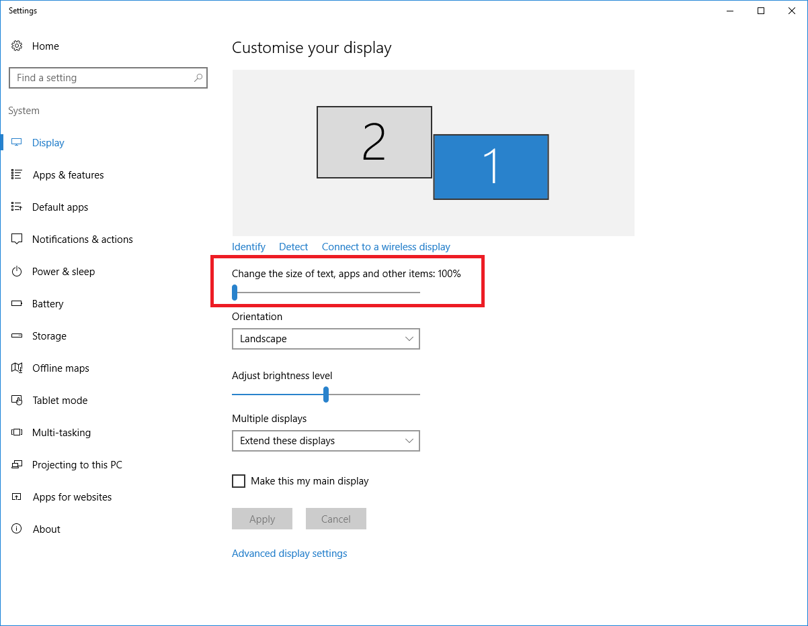
How workarounds you can:
- Set the "Change the size of text, apps and other items" property equal to 100% in the main display.
- If you have 2 monitors set the main display that has the property equal to 100%.
- Enable the "Disable display scaling on high DPI settings" property, that you can find in the properties of the NPrinting.exe application (C:\Program Files (x86)\NPrinting\Client), in the “Compatibility” tab. This option render the Designer layout enough bad.
