Qlik NPrinting behind a Reverse Proxy
Installing Qlik NPrinting behind a reverse proxy is fully supported starting from November 2018. If you are using an older version you must upgrade at least to November 2018 before proceed.

Introduction

What we will do
In this tutorial we will configure a reverse proxy by using NGINX and test it by connecting to Qlik NPrinting from a computer different from the one where it is installed.

Architecture
Qlik NPrinting Server and Engine will be installed in a single computer with the NGINX reverse proxy to simplify the architecture. Client connections will be generated from a different computer to test the configuration. NGINX could also be installed in a different computer to the Qlik NPrinting Server.
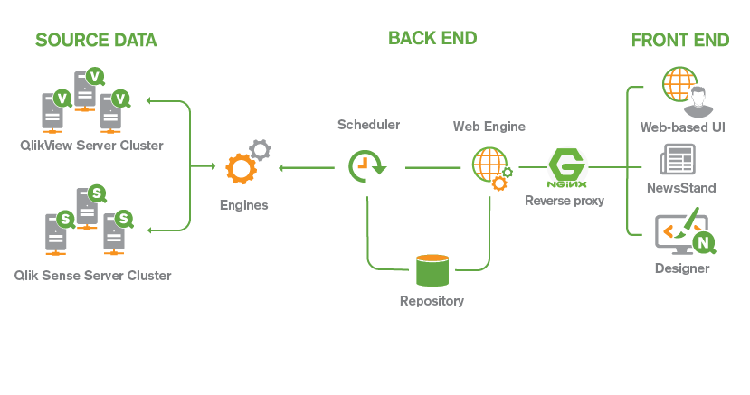

NGINX
Nginx is free and open-source web server which can also be used as a reverse proxy with caching. We will use it to create the reverse proxy for our tests.

HTTP
For using in production, we always suggest to keep the default configuration of Qlik NPrinting that uses https. In this tutorial we will use an http configuration instead to of http to simplify the NGINX configuration.
After configuring the connections that uses the reverse proxy the original URLs (for example http://HostName:4993 ) will still available. If you want to block them you could configure the Windows firewall of the Qlik NPrinting Server.
In this tutorial HostName indicates the name of the computer where Qlik NPrinting Server is installed.

Configuration

Configure Qlik NPrinting to use http connections
Qlik NPrinting supports also http connections and they can be activated by following the instructions in the help site page https://help.qlik.com/en-US/nprinting/September2018/Content/NPrinting/DeployingQVNprinting/Enabling-http.htm.
If you are using Windows login and it doesn’t work after activating http connections, delete the browser cookies and try again.
Before proceeding be sure that your Qlik NPrinting installation has the SMTP server correctly configured. Refer to the official instructions on the page https://help.qlik.com/en-US/nprinting/September2018/Content/NPrinting/AdministeringQVNprinting/Set-up-email.htm and remember to send the test email to be sure that everything is working correctly.

NGINX
Download the NGINX zip file for Windows from https://NGINX.org/en/download.html. In this tutorial we use the version 1.14.
Unzip the file in the selected installation folder. For example C:\Program Files\NGINX.
To configure NGINX enabling it to work as a reverse proxy, run your preferred text editor as an administrator, then open the configuration file C:\Program Files\NGINX\conf\NGINX.conf.
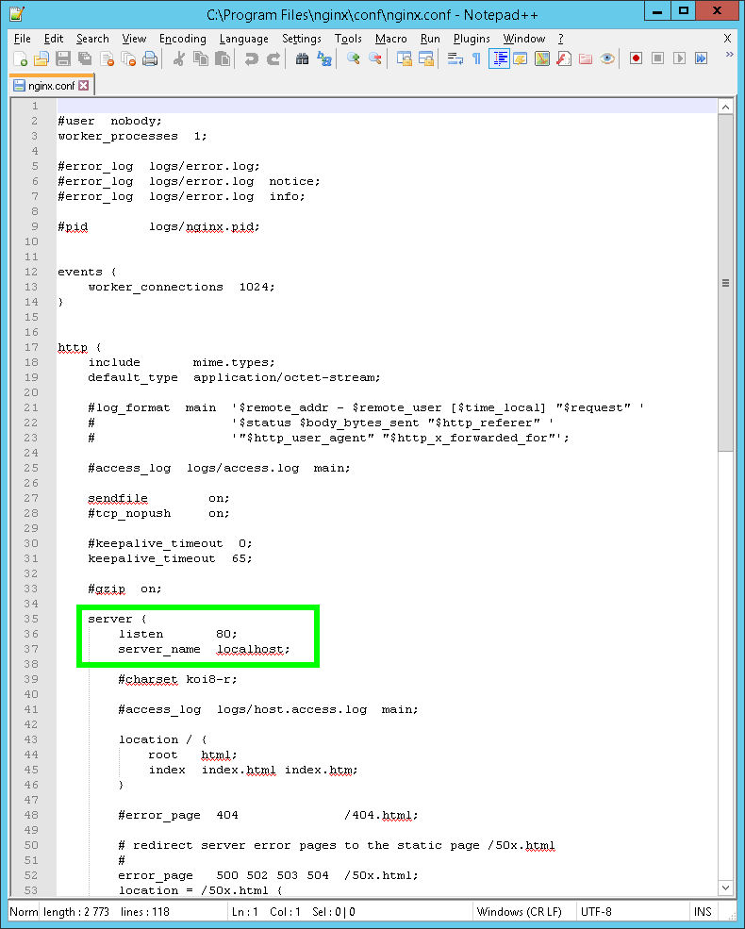
Over write and insert the information the following lines between the rows #gzip on; and #charset koi8-r;
NOTE: Ensure you replace “HostName” with the name of your NPrinting server
#gzip on

server {
listen 80;
server_name HostName;

location /webconsole/ {
proxy_pass http://HostName:4993/;
}

location /newsstand/ {
proxy_pass http://HostName:4994/;
}

#charset koi8-r;

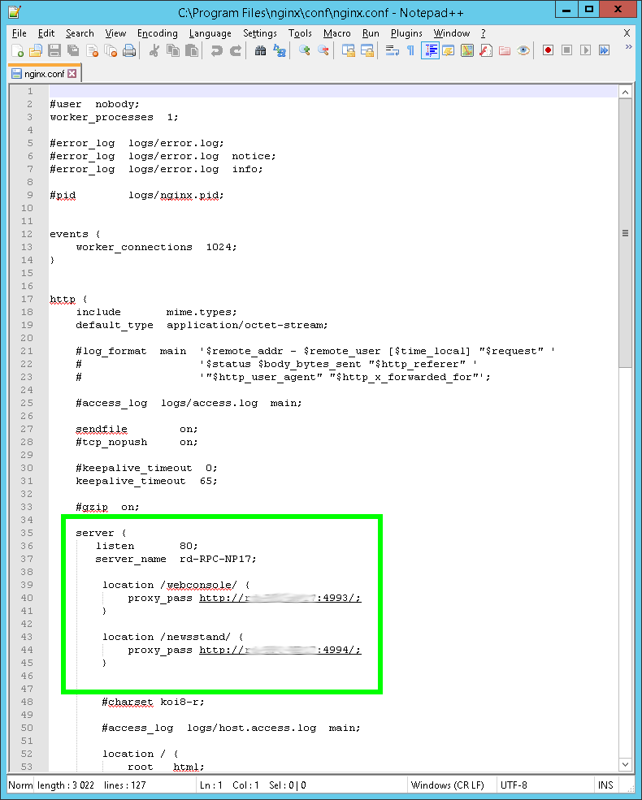
You could customize the two folders webconsole and newsstand with the values that you prefer.
Save the NGINX.conf file.
The two configuration lines with the location keyword instruct NGINX to send all requests that come to the /webconsole folder to the Qlik NPrinting Web Console and the requests that come to the /newsstand folder will be redirect to the NewsStand. For more details refer to the official NGINX documentation at http://NGINX.org/en/docs/http/ngx_http_core_module.html#location.
To start the NGINX reverse proxy by opening a Windows command prompt as administrator, then:
- Go to the NGINX installation folder by typing cd C:\Program Files\NGINX
- Start the NGINX reverse proxy with the command start NGINX.exe
- After pressing enter the command line appears again but the NGINX process is started. By opening a Windows Task Manager, you can see two NGINX processes named NGINX.exe (32 bit)
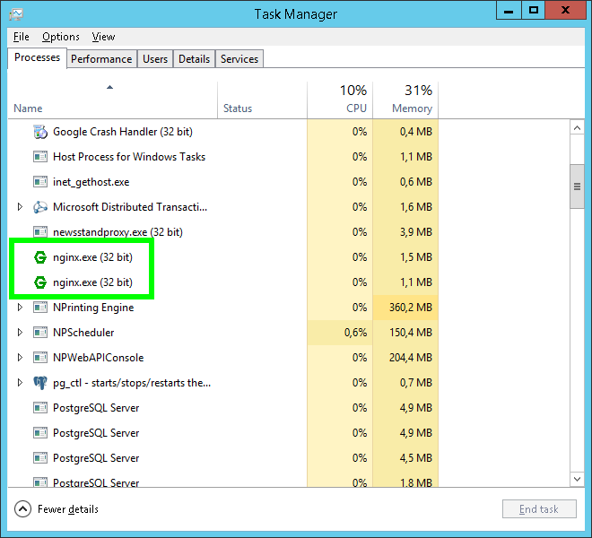
- When finished working with NGINX, you can stop it with the command nginx -s quit

Password
When you request to reset your password, Qlik NPrinting sends you an email with a link. We are using a reverse proxy so we must change the configuration of the password reset link in order to be consistent with the new configuration that uses subfolders.
Open your preferred text editor as administrator, then open the file C:\Program Files\NPrintingServer\NPrinting\WebEngine\webengine.config. Find the lines:
<!-- <add key="newsstand-address" value="<scheme>://<host>:<port>" /> -->
<!-- <add key="webconsole-address" value="<scheme>://<host>:<port>" /> -->
- Remove the comment tags <!-- and --> in both lines
- Customize both rows by adding:
  - http instead of <scheme>
  - Your host name and port number
  - The subfoldes webconsole and newsstand
  - The two configuration rows should look like:
<add key="newsstand-address" value="http://HostName/newsstand" />
<add key="webconsole-address" value="http://HostName/webconsole" />
- Stop and restart the Qlik NPrinting Web Engine Windows service
The HostName inserted in the webengine.config file must be the same as you inserted in the NGING configuration file NGINX.conf.

Basic Operations
All the web connections to the Qlik NPrinting server from this point are made by a different computer than the one where the Qlik NPrinting Server is installed.

Test the password reset procedure
Before proceeding we check that the password recovery procedure is working correctly for both Web Console and NewsStand.
Open the Qlik NPrinting Web console from your preferred web browser at the URL http://HostName/webconsole/. This link uses the NGINX reverse proxy.

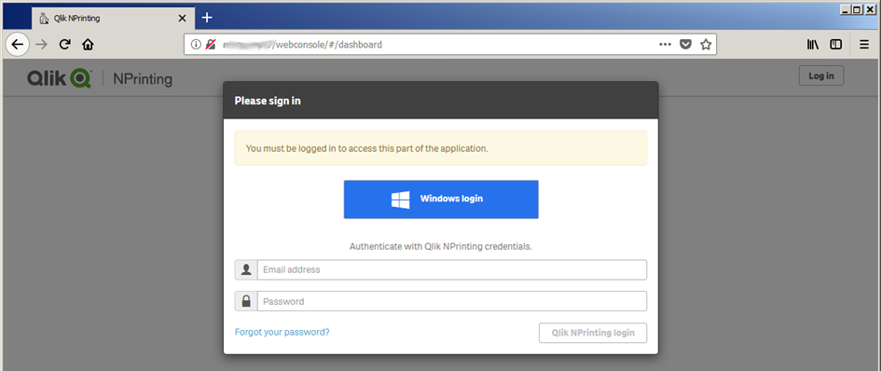
Click on Forgot your password? then insert your email and click on Reset password.
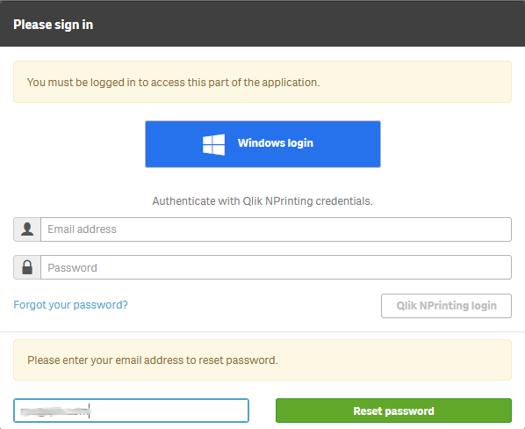
Check your email and open the message with the reset link.
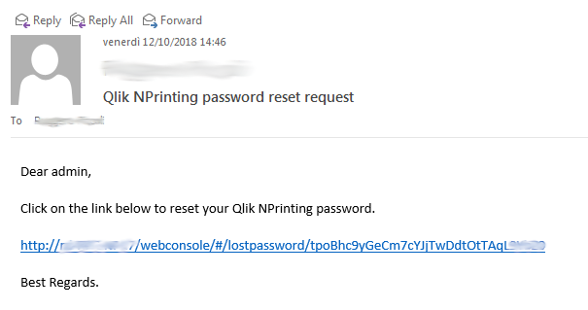
Note that the recovery link is in the correct format http://HostName/webconsole. Click on the link and insert your new password two times.
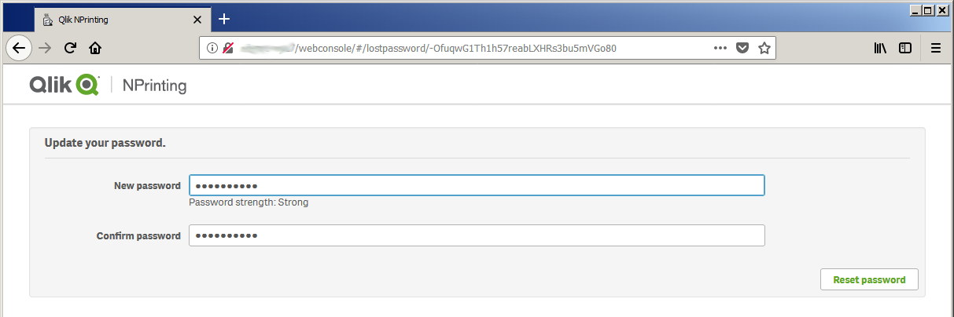
Press Reset password to confirm. A green message will appear on the screen.
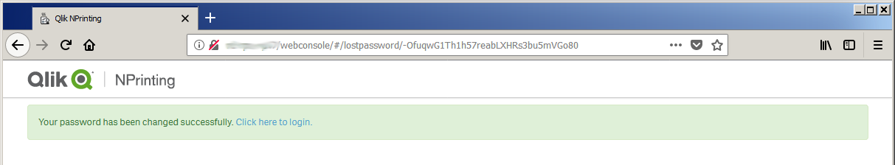
Repeat the same process for the Qlik NPrinting NewsStand by connecting to http://HostName/newsstand. If you are using the same user profile, of course, the credentials are the same but you need to check that the password recovery links work fine.

Web Console and NewsStand navigation
Open your preferred web browser in a different computer that the one where Qlik NPrinting Server is installed and open the Qlik NPrinting Web Console via reverse proxy at the URL http://HostName/webconsole/#/dashboard
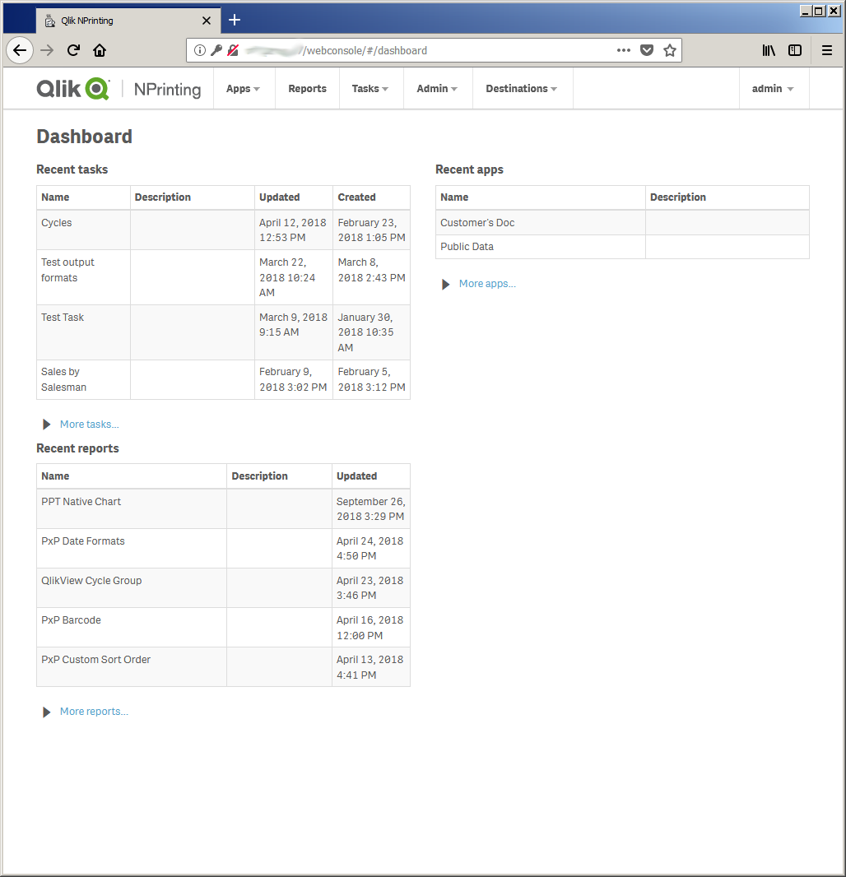
You can navigate the Web Console as usual. For example, you can open the connections page and regenerate caches.
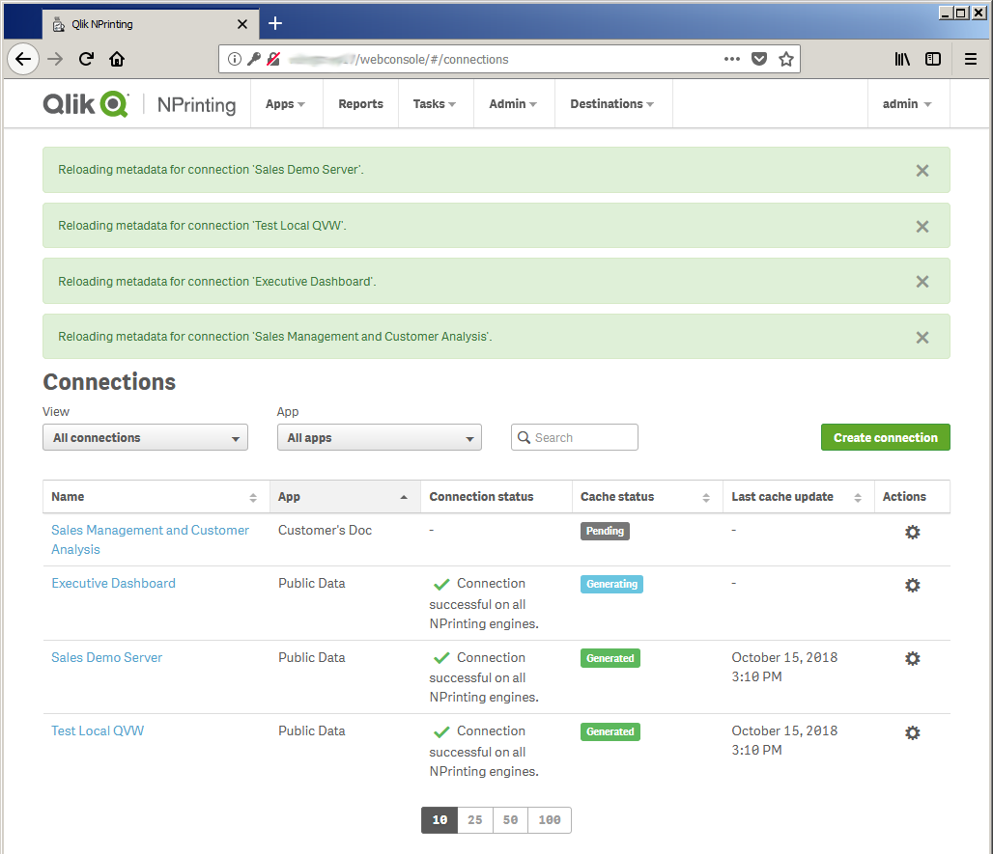
Open also the NewsStand via reverse proxy connection at the URL http://HostName/newsstand/#/reports
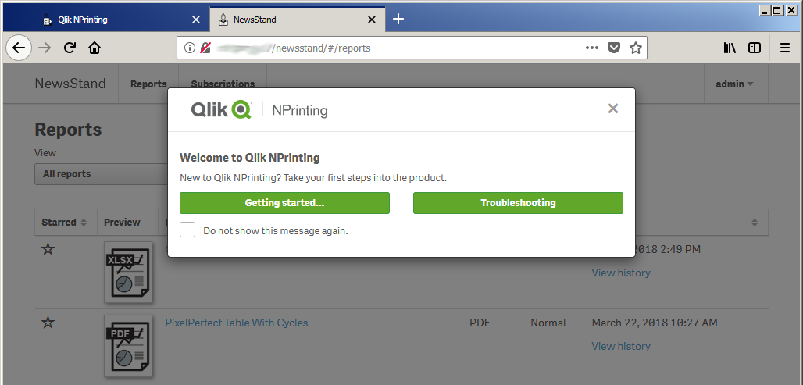
Test the NewsStand by opening report previews or download them
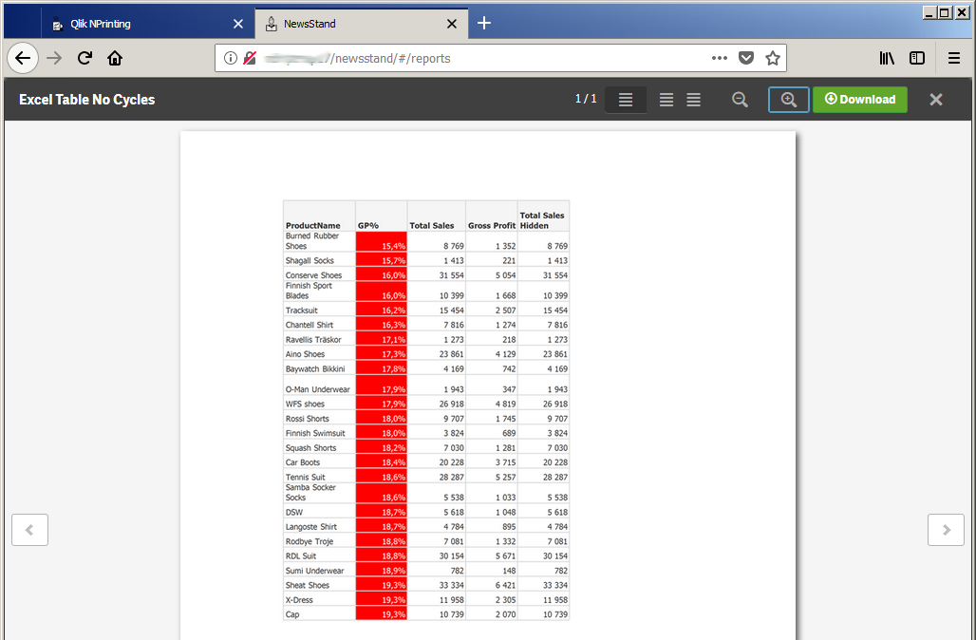

Report Editing
The editing of report templates can be done through a reverse proxy as you do without. Open the Reports page in the Web Console at the URL http://HostName/webconsole/#/reports
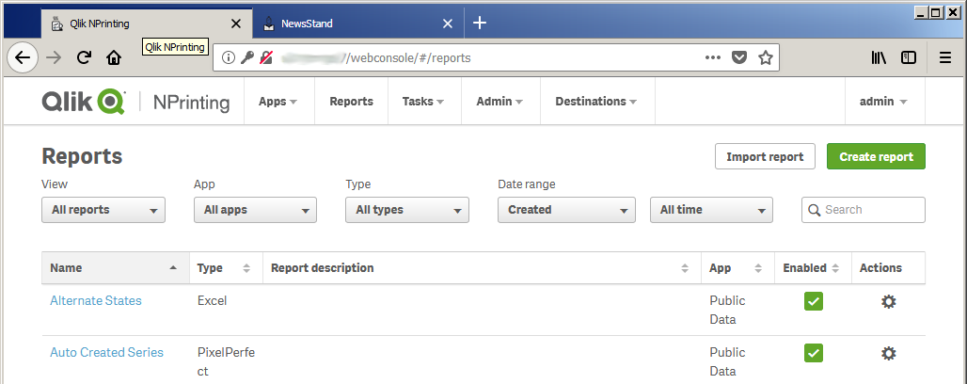
Click on Create report, fill the form as usual and click on Create.
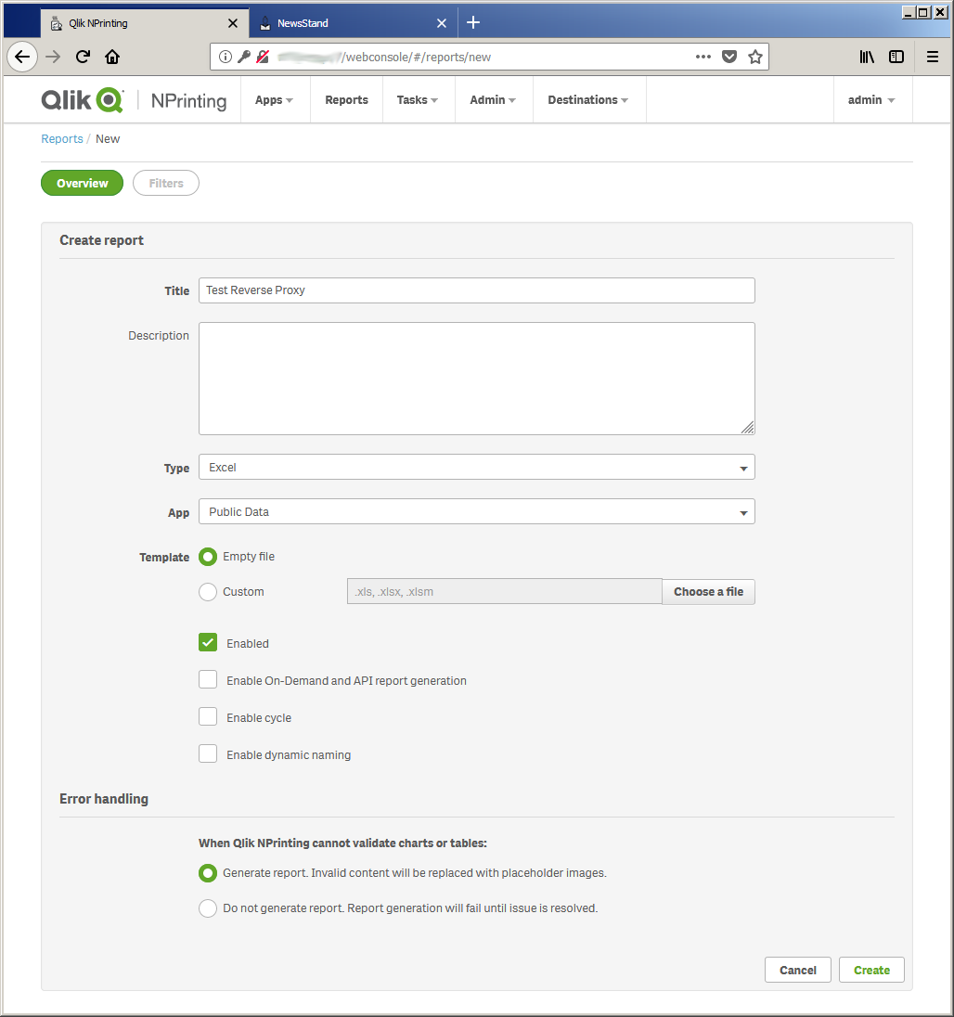
When you see the confirmation message click on Edit template
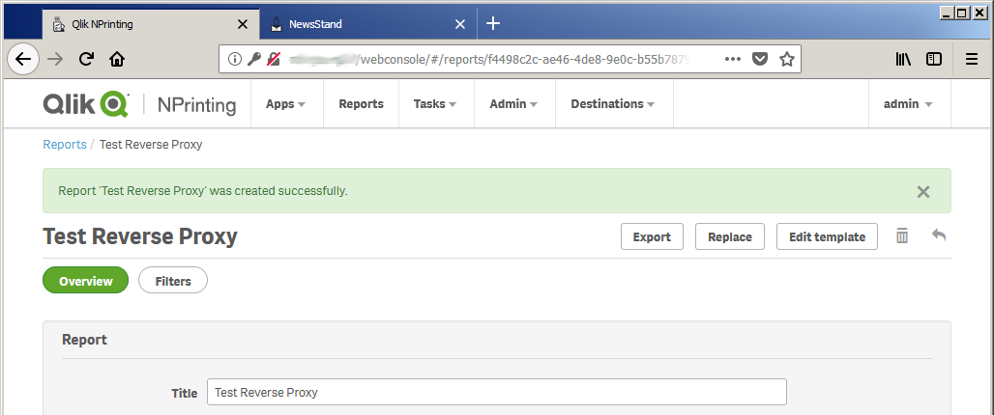
The Qlik NPrinting Designer is opened correctly. Add an object in the Tables node and drag and drop its tag into the template.
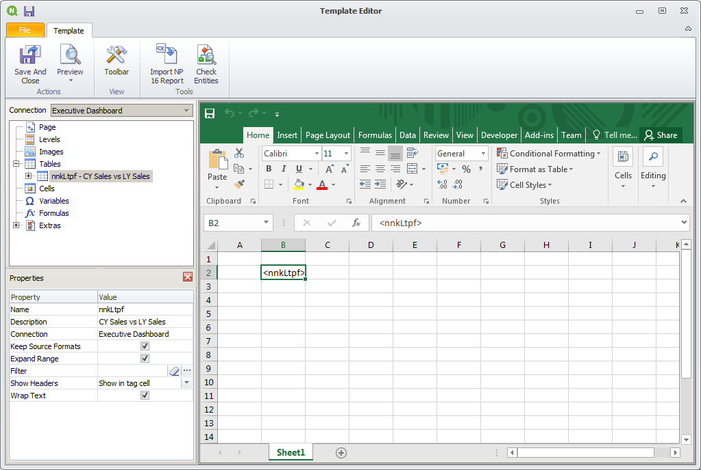
Run a report preview and see if it is generated correctly.

Save and close the Qlik NPrinting Designer.

Report Generation
Select Publish Task from the main menu bar and create a new task.
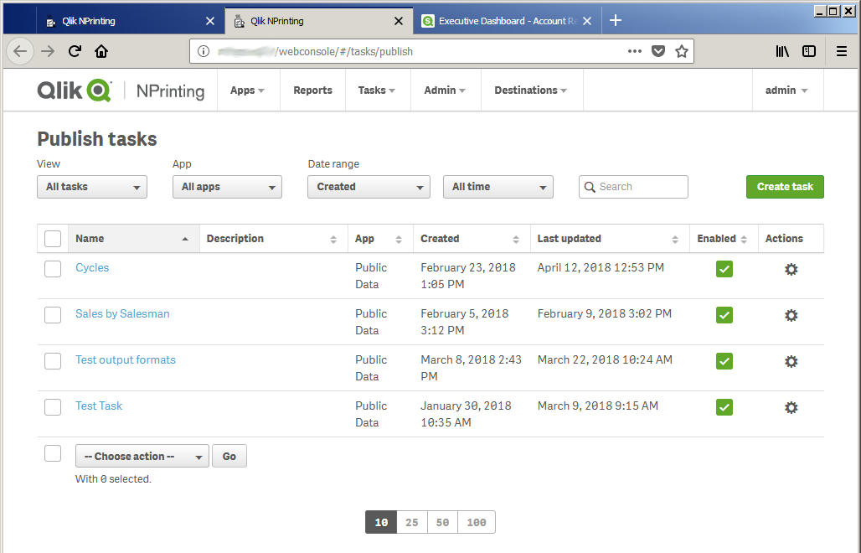
Fill the form as usual and click on Create.
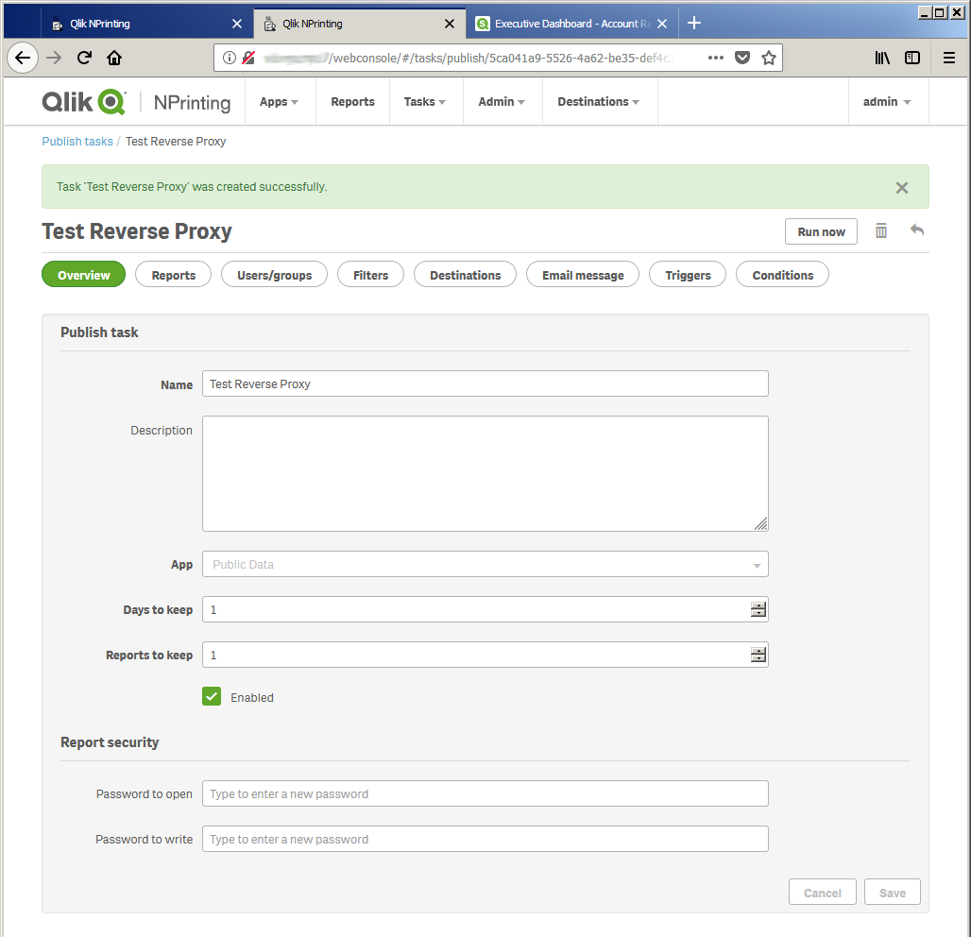
Add the test report you just created.
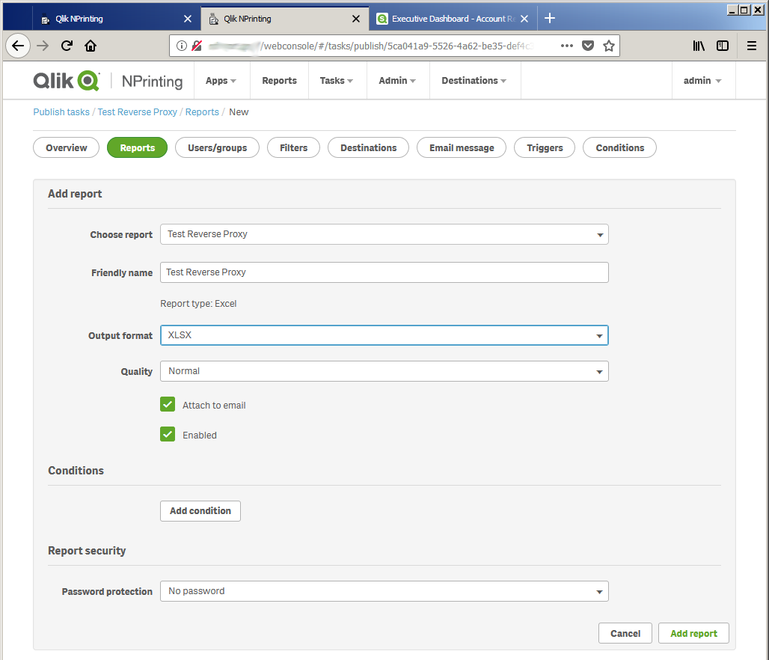
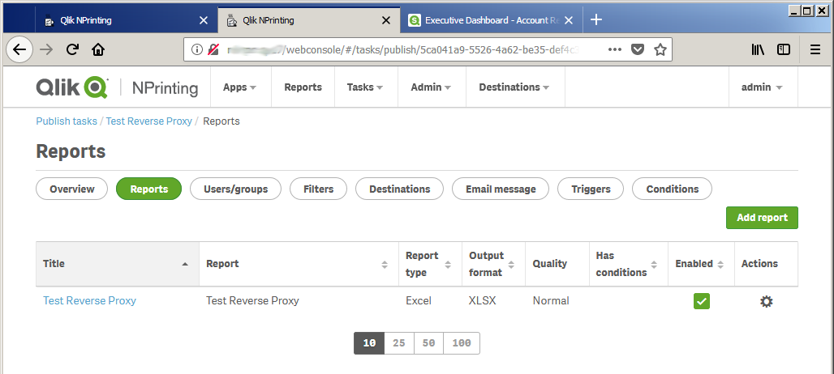
Add at least the user the you use to connect to the Qlik NPrinting NewsStand.
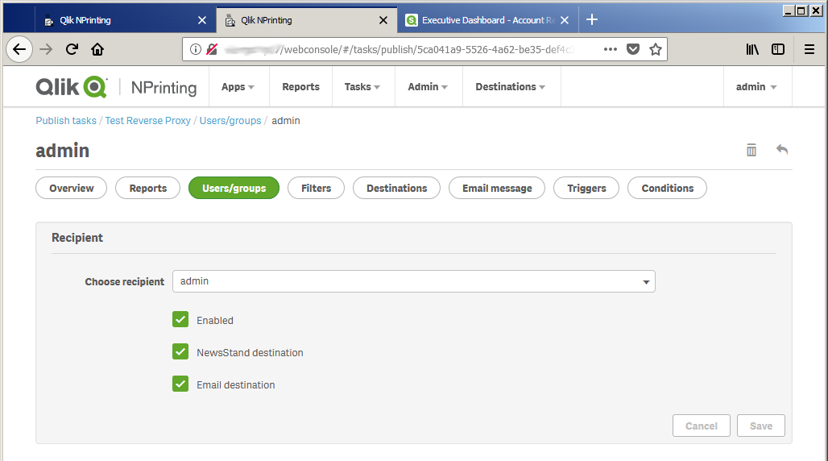
Run the task manually to check that everything is working fine. Open the Qlik NPrinting NewsStand and check the final result.
