Split standalone QlikView server into QVS and QDS node

In this scenario the standalone server QlikServer1 is running all QlikView 12 services. QlikServer2 is introduced as a new node. QlikView Distribution Service needs to be moved from QlikServer1 to QlikServer2, to create a QlikView Server node and a QlikView Publisher node in the same environment.
Prerequisite
- Valid QlikView Server license
- Valid QlikView Publisher license
- QlikView services running with a domain account
- QlikServer1 and QlikServer2 are members of the same domain
- Download QlikView Server installer to QlikServer2
- Required communication is open between QlikServer1 and QlikServer2

Confirm QlikView Publisher license
QlikView Publisher license must be applied to allow running QlikView Distribution service on a separate node. Follow steps below to confirm that QlikView Publisher license has been applied.
- Go to QMC > System > Setup, http://qlikserver1.domain.local:4780/qmc/SystemSetup.htm#
- Go to QlikView Publisher license, Licenses > QlikView Publisher
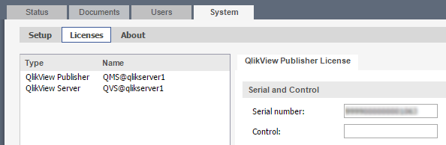
- Apply QlikView Publisher license it has not already been applied

Confirm fileshare path to document folders
QlikView Server and QlikView Distribution service utilize common files and folders, therefore these folders must be made available to both server nodes.
There is no need for action if network file share is already used. If QlikServer1 is using local folders, they must be moved to network file share or shared to the QlikView Service account.
QlikView Server Root Folder: C:\ProgramData\QlikTech\Documents
Source Documents: C:\ProgramData\QlikTech\SourceDocuments
QDS Application Data folder: C:\ProgramData\QlikTech\DistributionService
IMPORTANT: It is required that the shared folders are available as read and write to the QlikView Server service account.

Update folder paths to file shares
Before changing the server deployment structure, it is a good idea to confirm the file share paths are used in relevant settings. After altering all file path setting, validate that the services still operate as expected, but for example running a few sample tasks.

QlikView Server Root Folder And Mounted Folders
- Go to QMC > System > Setup, http://qlikserver1.domain.local:4780/qmc/SystemSetup.htm#
- Expand the QlikView Servers node
- Select current QVS node
- Go to Folders tab
- Set Root folder and all mounted folders to fileshare paths
- Apply changes 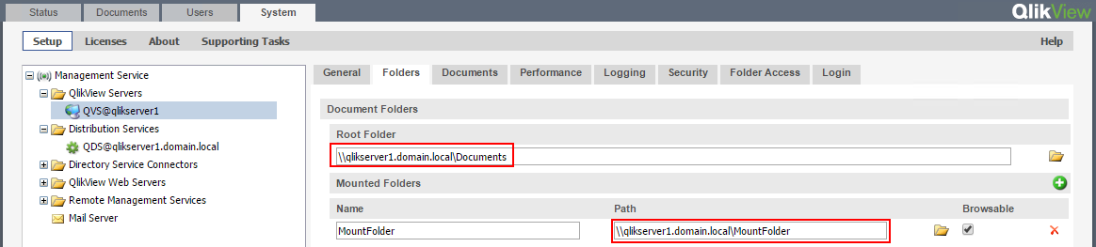

QlikView Distribution Service Application Folder And Source Documents
- Go to QMC > System > Setup, http://qlikserver1.domain.local:4780/qmc/SystemSetup.htm#
- Expand the Distribution Services
- Select current QDS node
- Go to General tab
- Set Application Data folder and all Source Folders to fileshare paths
- Apply changes
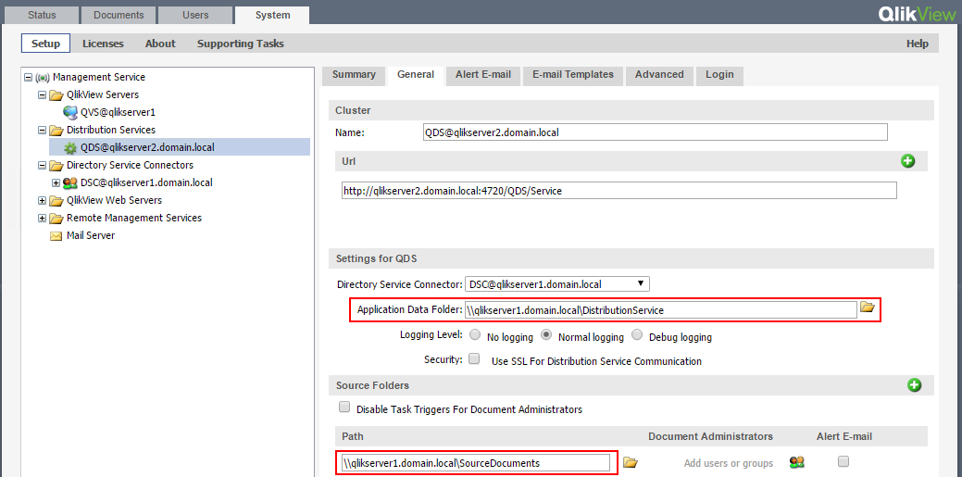

Task Distribution folders
Tasks can be configured to output distribution to custom folder of a task level. Meaning this will not follow the QDS service level setting. If this feature is used the folder paths must be updated to valid fileshare path on all tasks.
- Go to QMC > Documents > Source Document, http://qlikserver1.domain.local:4780/qmc/SourceDocuments.htm#
- Expand task with custom distribution path
- Select associated taks
- Go to Distribute > Manually
- Change distribute to Folder path to valid fileshare path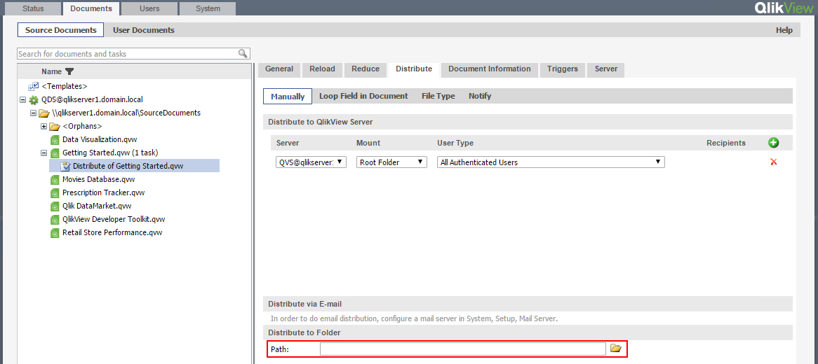

Install QlikView Distribution Service
- Run QlikView Server installer on QlikServer2
NOTE: It must be the exact same version as currently installed on QlikServer1
- Go through setup wizard, and install QlikView Distribution Service and QlikView Directory Service Connector
  - In profiles selection, select Config in lower left corner
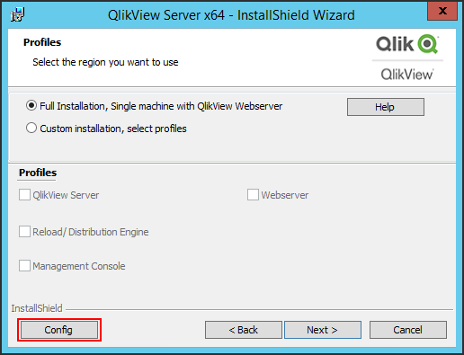
  - Exclude the other services
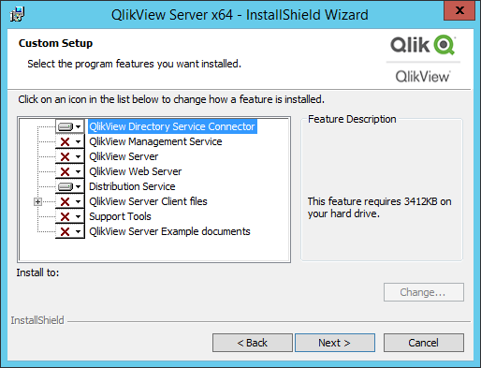
  - When asked for service account, apply same domain account as on QlikServer1
- After installation the services have been installed under C:\Program Files\QlikView;
  - Directory Service Connector
  - Distribution Service
- Restart Windows Server on QlikServer2 to apply installation
- Confirm services are running with correct domain account
- Test new services from browser in QlikServer1, by accessing DSC and QDS services;
  - DSC: http://qlikserver2.domain.local:4730/DSC/Service
  - QDS: http://qlikserver2.domain.local:4720/QDS/Service

Configure Directory Service Connector
By clustering the DSC nodes redundancy can be achieved. If one service goes down, the other will step in as a failover.
- Go to QMC > System > Setup, http://qlikserver1.domain.local:4780/qmc/SystemSetup.htm#
- Expand Directory Service Connectors node
- Select the current DSC
- Go to general tab
- Add new DSC URL
- Apply change
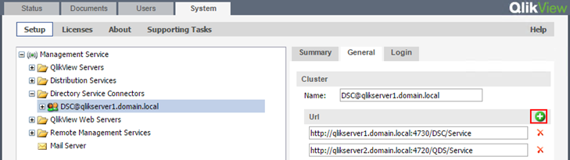

Change Distribution Service Node
- Go to QMC > System > Setup, http://qlikserver1.domain.local:4780/qmc/SystemSetup.htm
- Expand Distribution Services
- Select current QDS node
- Go to General tab
- Change URL to new QDS service; http://qlikserver2.domain.local:4720/QDS/Service
- Change QDS name; QDS@qlikserver2.domain.local
- Apply change
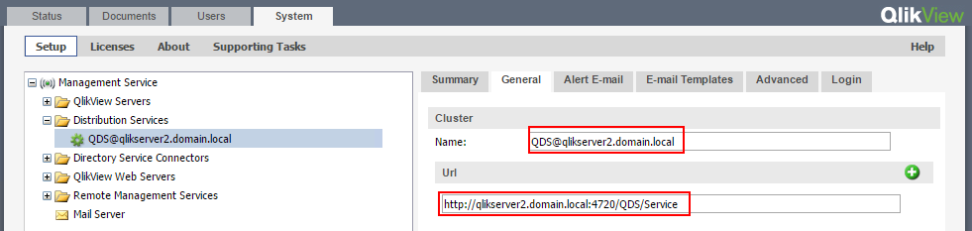
- Go to QlikServer2 and restart QlikView Distribution Service
- Stop and disable QlikView Distribution Service on QlikServer1
- Confirm that reload tasks execute accurately

