QMC Access Creation using Custom Property.
- Assign a Role to the Users.

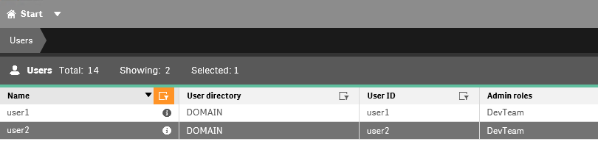

- Create a Custom property with resource type Apps, Streams, Reload Tasks. This is used for restricting Stream and associated resource Access.
Note: You can ignore Custom Property if you do not want to restrict users from accessing all Streams and Apps.

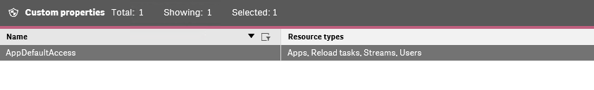

- Create a Stream and Assign the Custom property. No need to create security rule now, since we will be creating custom rule in later steps.
Note: If you need provide stream access on HUB then you can create a rule with context HUB.

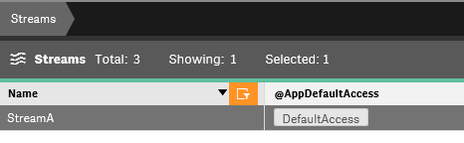
- Create a Sec Rule for QMC Section Access.

Resource Filter: QmcSection_App,QmcSection_App.Object,QmcSection_Stream,QmcSection_Audit,QmcSection_ReloadTask,QmcSection_Tag,QmcSection_User,QmcSection_DataConnection,QmcSection_SystemRule,QmcSection_Task,QmcSection_CompositeEvent,QmcSection_SchemaEvent

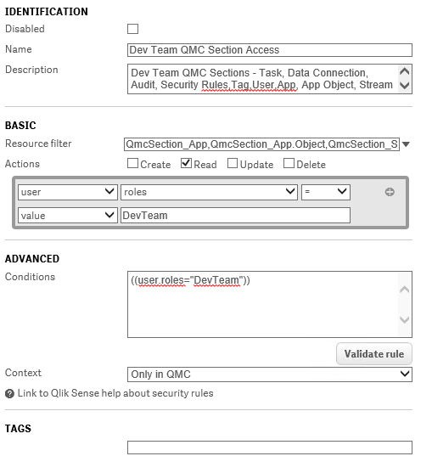

- Create a Sec Rule for Resource Access

Resource Filter: Stream_*,App_*,App.Objects_*,ReloadTask_*,SchemaEvent_*,Tag_*,DataConnection_*,CompositeEvent_*

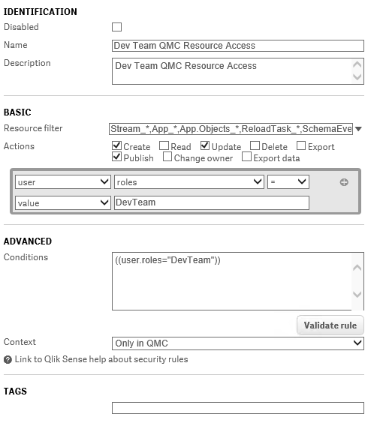

- Create a Sec Rule for restricting users from accessing all resources like Streams, App, App Objects and Data Connection, tasks

Resource Filter: App*,ReloadTask_*

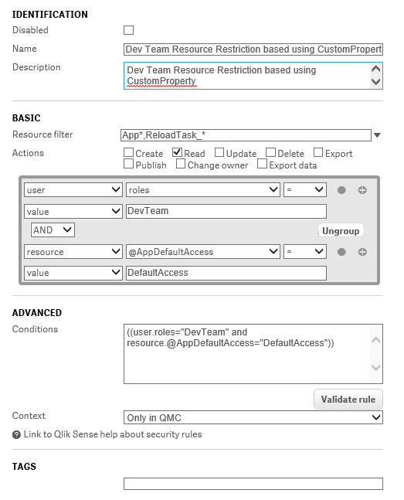

- Create a Sec Rule for Accessing Security Rule and Users. Here we are providing Read access only.

Resource Filter : SystemRule_*,User_*

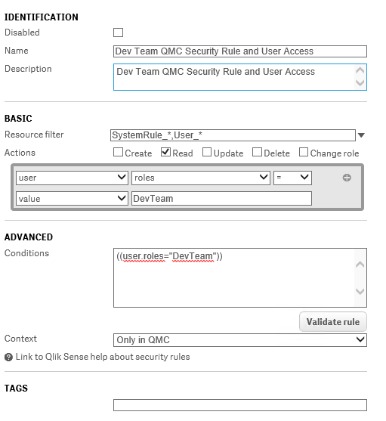

- Create a sec rule for Triggers. Note: Triggers are like child resource of Tasks. So when restricting users in QMC we need to create a separate rule for this.
Note: If there is no restriction on Stream, App and Tasks, then do not need this rule setup.
Resource Filter : CompositeEvent_*,SchemaEvent_*

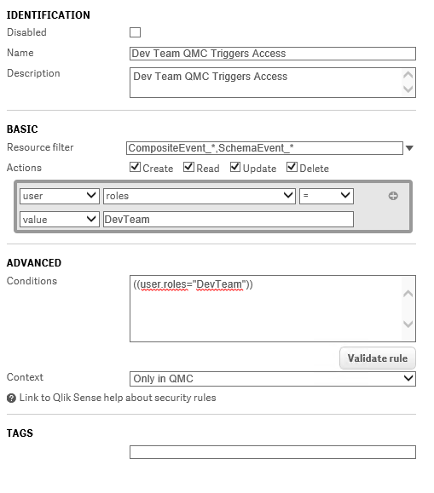

- Finally, we need to create Sec Rule for Custom property. Since if a new app is created , we need to provide custom property to make it visible.
Filter Resource : CustomProperty*

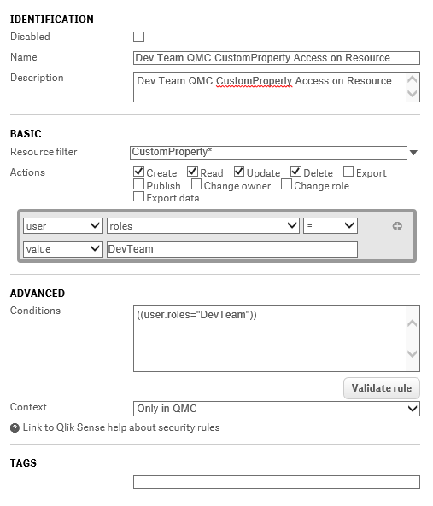

- Validate the scenario by logging with User1 and User2.

