For instance Partialreload app in everyone stream
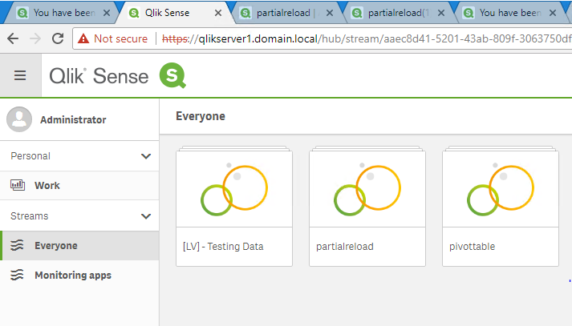
There is on sheet

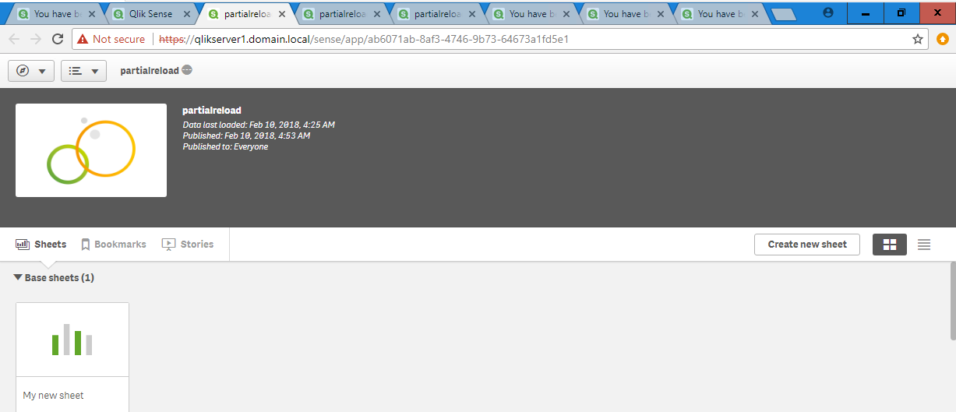

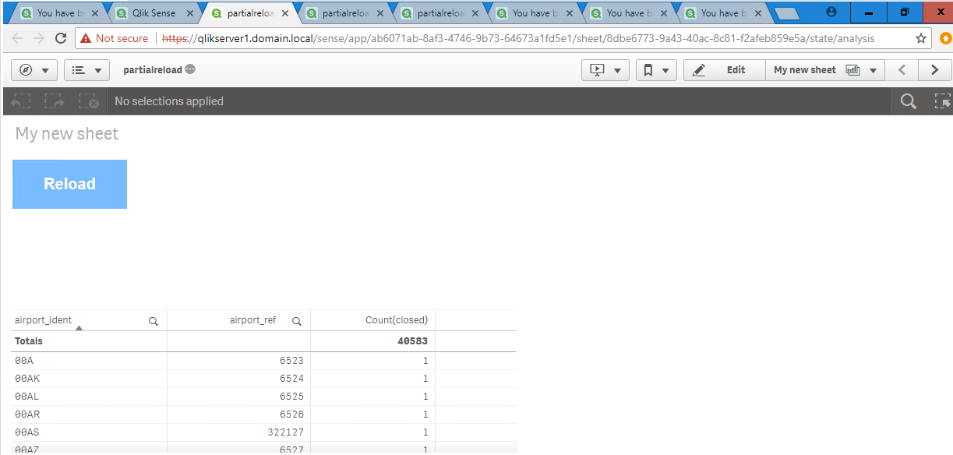
Duplicate this sheet then publish it

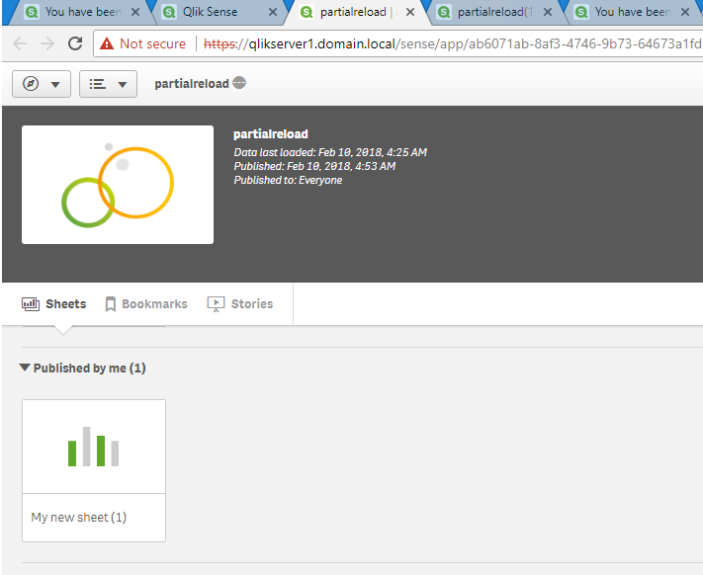
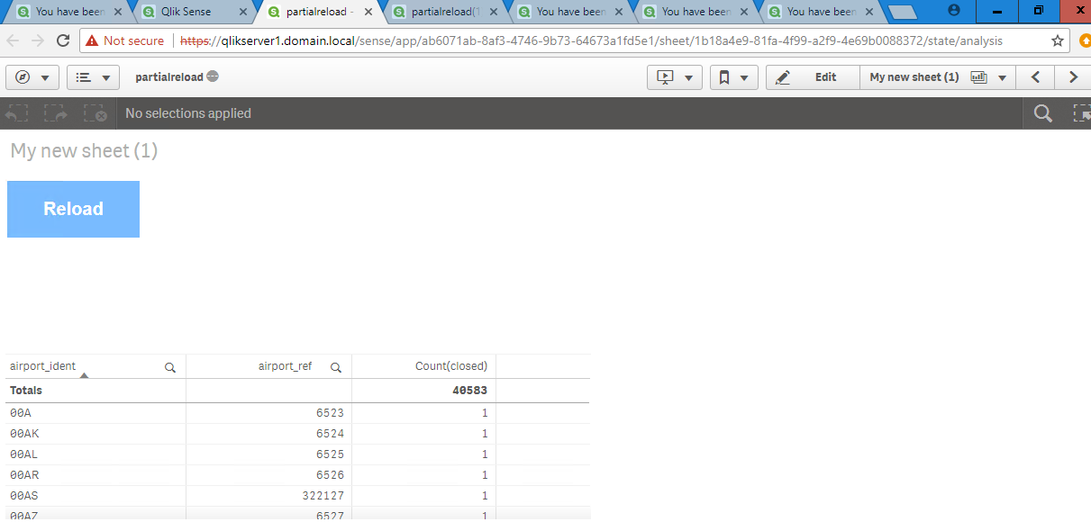

When other users open the app from everyone stream, this sheet is published to the community
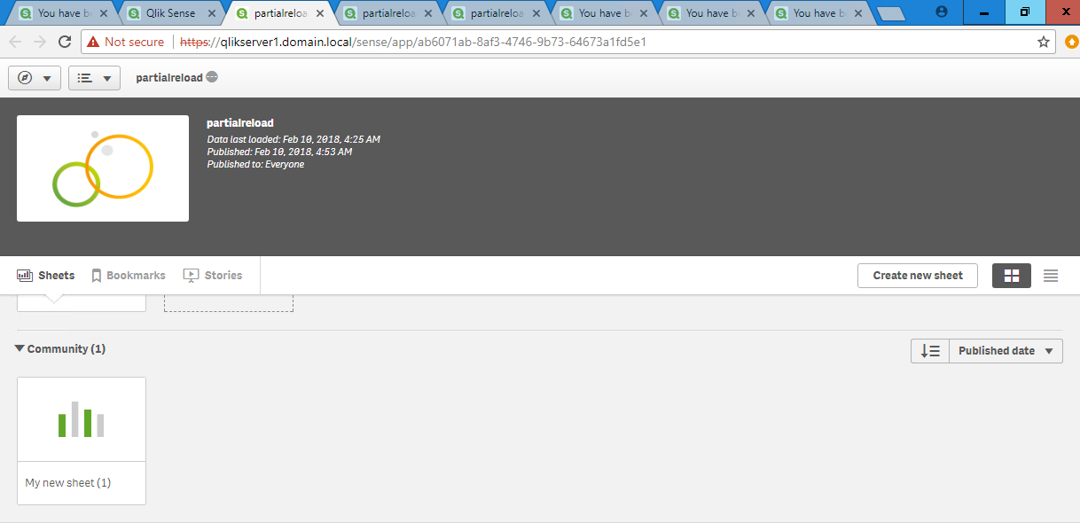

Export this app from QMC. Change the name then import into QMC
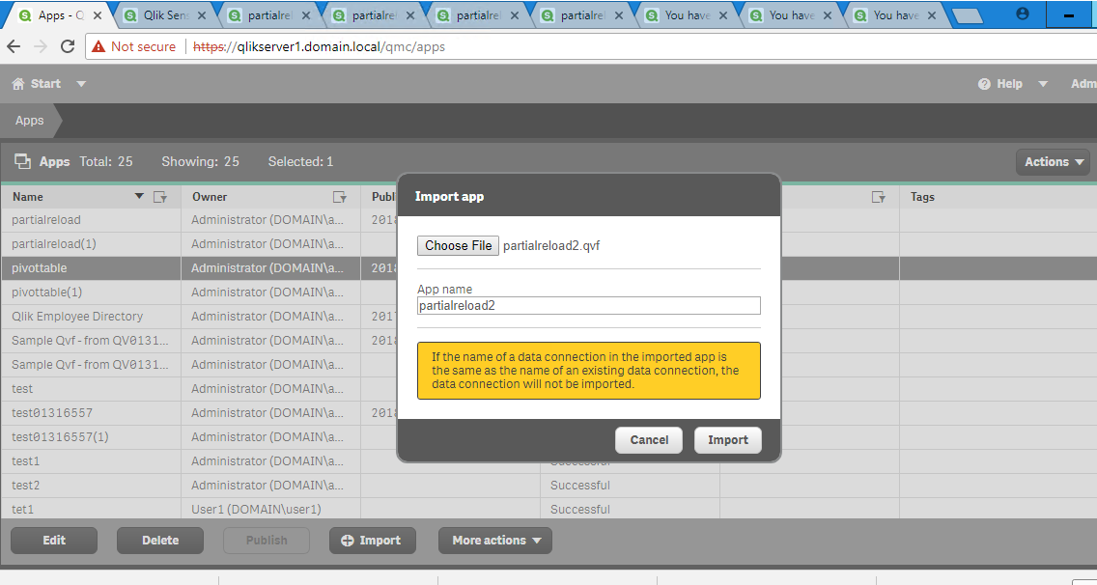
Publish the app to everyone stream. Then open, it does not include the published sheet.

Now duplicate the partialreload app.

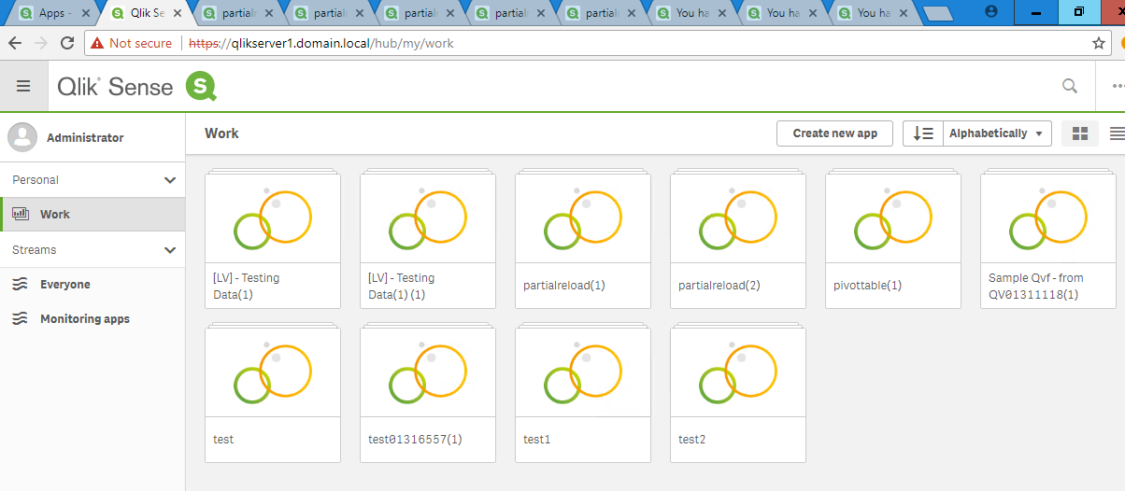
Open the duplicated app, the app does not contain the published sheet.

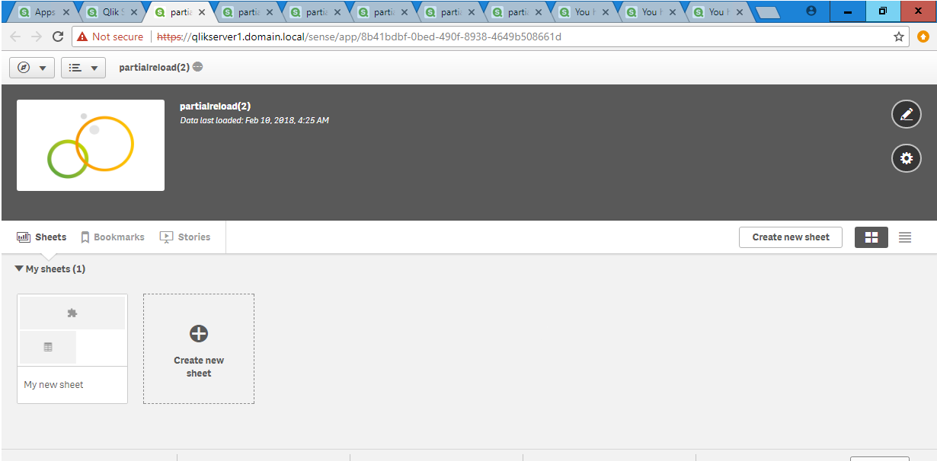
Install QMC untilities from https://github.com/eapowertools/QlikSenseQMCUtility/wiki/QMC-Utilities-Installation-Instructions
Then on QMC untilities, approve the published sheet for partialreload app

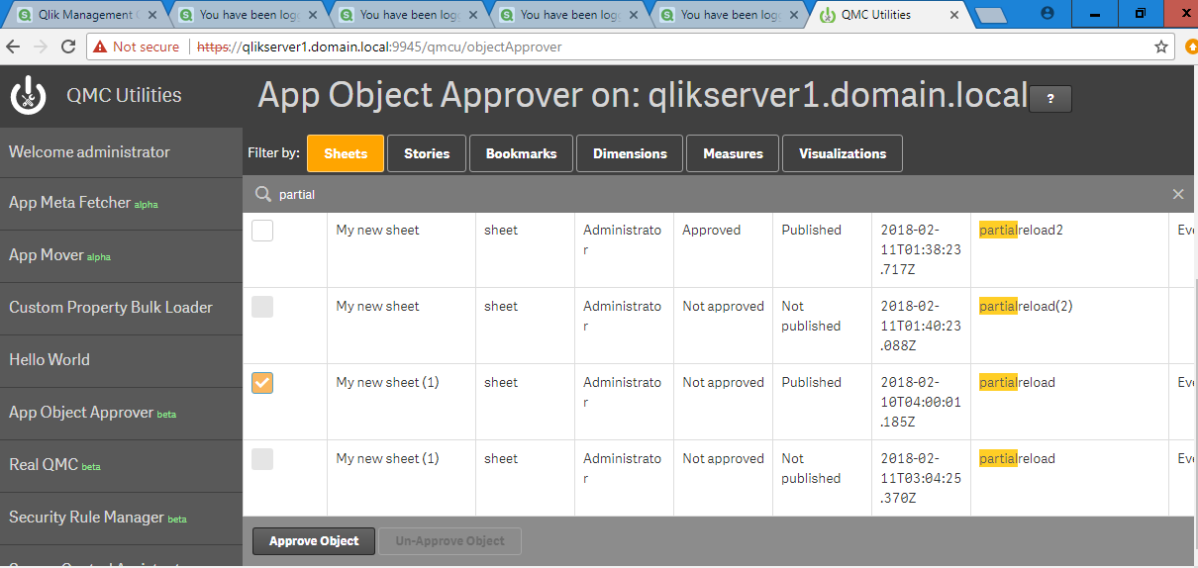

In QMC, duplicate the partialreload app, then open the app. Published sheet becomes base sheet now.

