Scenario Required:
Stream A has application 1, application 2, application 3.
User 1 can only see application 1, cannot see application 2 and application 3 of stream A.
User 2 can only see application 2, cannot see application 1 and application 3 of stream A
- Create StreamA: Created a StreamA with 3 apps published into
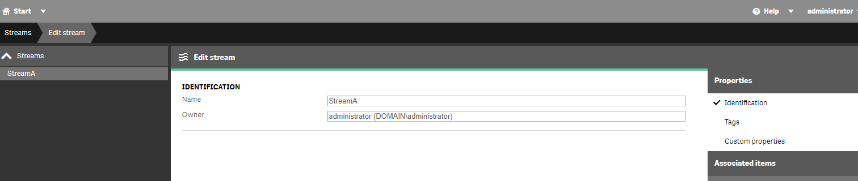

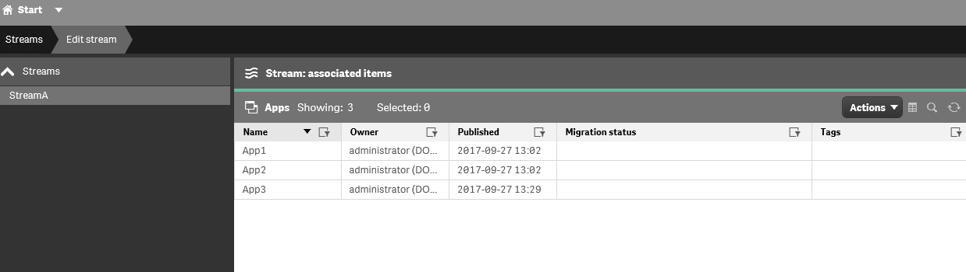

- Create a security rule for the stream and provide access to User1 and User2
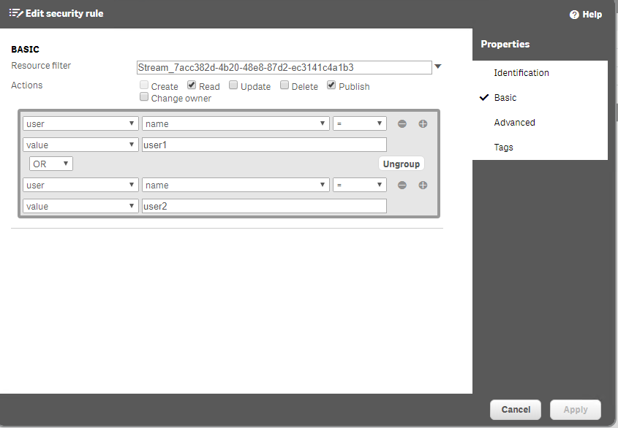

- Now User1 and User2 will be able to see the StreamA with all apps.
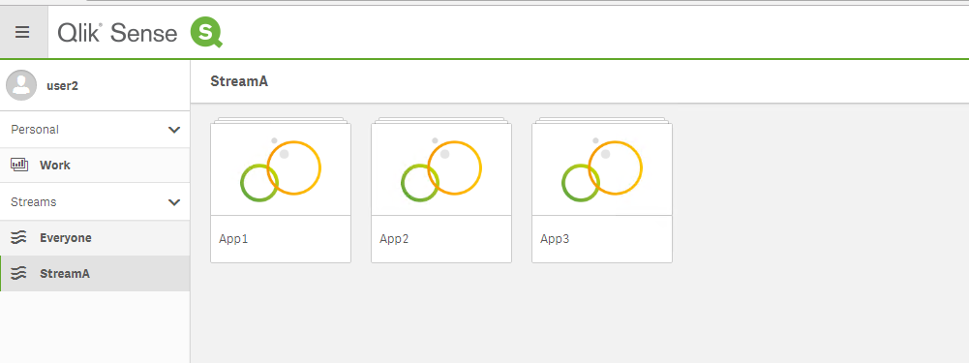

- Disable the default rule “STREAM”, since this rule will allow read access to all apps if the user have permission to Stream level.

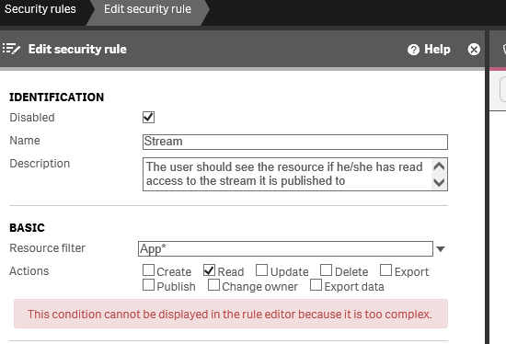

- Create a custom property with Resource Type Apps and Users.
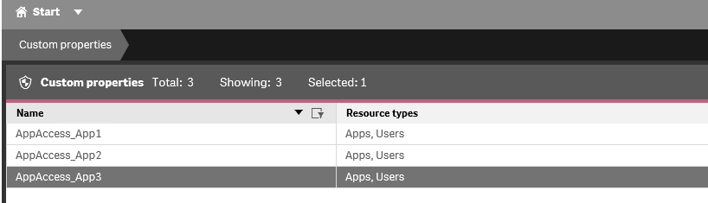

- Assign the Custom Property to the Resources. Example: for Apps and Users like below. Do it for other user apps. So, each custom property created should be associated with the correct apps.

For App1 : CustomProperty = App1
For App2 : CustomProperty = App2
For App3 : CustomProperty = App3

For User1 : CustomProperty = App1 , App3
For User2 : CustomProperty = App2 , App3

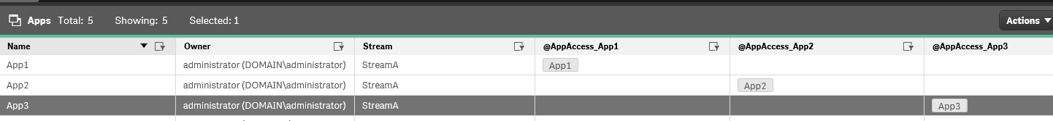

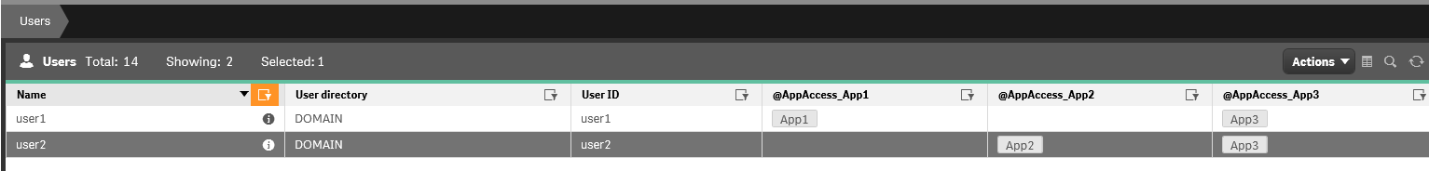

- Now finally create a Custom Security Rule for Apps.
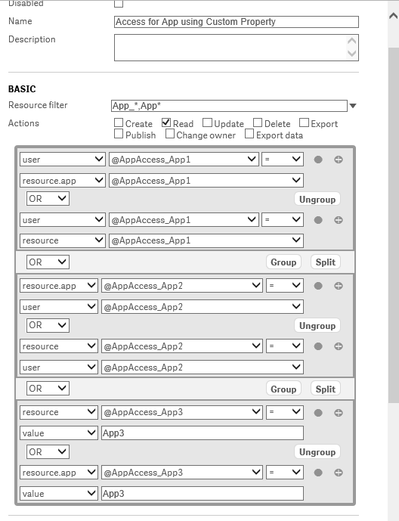

Now validate the result. Log into the hub with both the users.
